Privacy Preserving Blockchain & ML Hybrid System for Adaptive Financial Fraud Detection

ABSTRACT
With the exponential rise in digital financial transactions, the threat of fraudulent activities has grown more sophisticated and pervasive. Traditional fraud detection systems, which rely heavily on centralized machine learning (ML) models, are increasingly vulnerable to data tampering and cyberattacks. A compromised database can significantly degrade the performance of ML algorithms, leading to incorrect predictions and enabling malicious transactions to slip through undetected. To address these limitations, this research introduces an innovative approach that combines Blockchain technology with incremental machine learning to build a privacy-preserving and tamper-proof fraud detection system. The system ensures that trained ML model weights are securely stored on the blockchain, making unauthorized alterations virtually impossible due to the cryptographic hashing and immutability inherent in blockchain architecture.
This framework employs multiple machine learning algorithms such as Passive Aggressive Classifier (PAC), Stochastic Gradient Descent (SGD), Perceptron, and Naïve Bayes, each trained incrementally on large-scale transactional data. Training is split across two difficulty levels—Level 1 (10,000 records) and Level 2 (30,000 records)—to evaluate the adaptability and time efficiency of each model. To handle data imbalance, the SMOTE technique is used for oversampling. The best-performing model (SGD with 99.83% accuracy) is selected based on metrics like accuracy, precision, recall, and F-score, and its learned weights are stored securely on the Ethereum blockchain using a smart contract written in Solidity. This contract allows for decentralized and secure storage of model weights, making them retrievable by any authorized organization for real-time prediction.
Incentives for blockchain mining are managed dynamically based on data difficulty levels to reduce computational delays. A user-friendly Flask web application is also implemented for administrators to upload transaction data and view fraud predictions in real-time. This combination of machine learning, blockchain, and smart contracts provides a scalable, tamper-proof, and adaptive solution for next-generation fraud detection systems.
.
Keywords:
Blockchain, Incremental Machine Learning, Fraud Detection, Passive Aggressive Classifier (PAC), Stochastic Gradient Descent (SGD), Perceptron, Naïve Bayes, SMOTE, Ethereum, Smart Contract, Solidity, Flask, Privacy-Preserving, Tamper-Proof, Decentralized System.

INTRODUCTION
Financial fraud has been a serious matter of concern in the business community. Even with technological advancement, fraud cases are on the rise [1]. According to the recent Juniper Research report [2], merchants are expected to suffer a cumulative loss of $206 billion due to online transaction fraud within the years 2021-2025. Robust fraud detection algorithmic model development requires authentic data. However due to the confidential nature of financial data, privacy concerns, and lack of synergy between organizations, financial transaction data is rarely available for machine learning research [3], [4]. On top of that, organizations often abstain from collaborative research on financial cases to conceal their financial statements and business strategies [4]. Large enterprises around the world own maximum of systems and services, and a massive amount of data is also at their possession [5]. Researchers from small organizations often rely on crowdsourcing to acquire data, which is susceptible to spoofing and often proves to be completely unusable [6] On the contrary, isolated and proprietary intra-organization solutions often become biased to single evidence where an ML model is trained only with intra-organizational data and often fails to represent the overall distribution in real-world systems [7]. For Machine Learning (ML) systems to be reliable and accurate, authentic real-world data is necessary. However, such data are rarely available due to privacy concerns, as we explained earlier. The traditional batch-trained machine learning techniques prove to be inharmonious with the online use cases such as transaction fraud detection [8]. High-traffic platform such as e-commerce deal with a high volume of data flow. As a result, an offline ML model (batch-trained) becomes incapacitated over time and requires a manual update, which is computationally costly, laborious and impractical in an online scenario [9]. On top of that, batch-learning approaches lack the capability to incorporate insights from new data instances in a deployed (online) ecosystem [10]. Incremental machine learning is a potential solution that can aid the purpose of keeping the model updated over time, minimize the computation cost, and avoid manual updates [11]. ML algorithms learn from a data stream in an incremental machine learning approach while the model is already in service [10]. Yet, to incrementally build a better fraud detection ML model, a continuous supply of data is essential so that the model is consistent with the new trends in fraudulence. This study proposes the solution to privacy issues in building an ML model incrementally using blockchain and smart contract technology. Research work by Tiernanm Barry provides empirical evidence that, in the online ecosystem, batch-trained ML models become imprecise and unreliable over time. In contrast, incremental ML models evolve over time and adapt to new data [9]. His study on predicting the next-minute price of three major crypto-currencies reveals that incremental online learning delivers the best performance, beating batch learning. The study by Chao Yang proposes a blockchain-based incremental outlier clustering technique that is computationally less expensive and more effective in terms of performance [12]. Blockchain technology is progressively being adopted to enhance system security while machine learning techniques are used for their predictive capabilities [13]. Taking advantage of both these technologies (ML and blockchain), Justin D. Harris and Bo Waggoner proposed a platform for collaborative machine learning [14] where a combination of incentive mechanism and data handler provides the functionality to train a machine learning algorithm on the fly collaboratively. However, their approach did not incorporate the case of corporate privacy, adaptive incentive, and specific mining criteria, [14] which are the vital aspects of the collaborative and distributed ecosystem. Furthermore, privacy is an uncompromisable aspect in businesses like e-commerce, where data contains business insights and the personal information of the consumers [15]. Considering these issues, our paper proposes a novel blockchain and smart-contract-based privacy-preserving solution for e-commerce where a fraud detection model is incrementally trained, maintained and updated. The feasibility of blockchain technology and smart contracts in collaborative and distributed machine learning has already been studied [16]. To ensure safe collaboration, privacy preservation is preliminary. Our approach comprises testing several machine learning algorithms on an initial dataset to select one algorithm. After the initial selection, the machine learning algorithm is stored within a blockchain network to be used by any organization and to be incrementally upgraded. Smart contracts are stored within the blockchain so that the contract itself is immutable and unalterable. These contracts serve the best version of the ML model, maintain the incentive mechanism and deal with the model update calculations automatically. To ensure data privacy, sophisticated data provided by the organizations is not shared in the central storage. Instead, the model training is done off-chain (within the organization), and only the metric is stored in the system. While incrementally updating the model by the system, the smart contract will always point to the current best model which is made available to the users. A combination of precision, recall, f-score and false-negative rate is used to update the current best ML model with a newer version. A difficulty-adaptive incentive mechanism has also been engineered to encourage the organizations so that their efforts are awarded fairly. The more difficult it is to update a model, the more incentive is disbursed. As ML, blockchain and smart contract-like cuttingedge technologies are being used together, the efficiency of the overall system has been tested under varying difficulty levels and data volume. Finally, blockchains’ cryptographic distributed ledger technology secures all the information stored. To the best of our knowledge, no study has yet contemplated the case of collaborative, incremental financial fraud detection while ensuring privacy and security using smart contracts and blockchain technology. Our main contributions are summarized as follows. • We proposed a privacy-preserving approach so that business organizations (e-commerce in this case) can build robust ML models incrementally. • Our study proposes a difficulty adaptive incentive mechanism that incentivizes the contributor based on the level of difficulty to update a machine learning model with a newer version. • To update a model with a newer version, a mining criteria has been proposed which utilizes a combination of model metrics to take the decision of mining a block. The mining criteria have been designed explicitly for high-traffic real-world systems like e-commerce. • We have experimented with the mining time to test the system’s efficiency for different blockchain mining difficulty levels and with different volumes of data to train the models. The rest of the paper is documented as follows. Section 2 contains the background study on our topic, delineating the research progression. Section 3 describes our machine. learning model, dataset and feature selection. This section also explains the selection procedure of the ML model and the evaluation criteria. While section 4 provides a detailed architecture of our system, section 5 exhibits the implementation details. The results of system testing have been shown in section 6. After a discussion about the system implications in section 7, the paper is concluded in section 8.

OBJECTIVE:
- To design a privacy-preserving and tamper-proof fraud detection system by integrating Blockchain technology with Incremental Machine Learning.

- To evaluate multiple incremental ML algorithms (PAC, SGD, Perceptron, and Naïve Bayes) on large-scale transactional datasets and select the most efficient model based on performance metrics.

- To implement secure and decentralized storage of trained ML model weights on the Ethereum blockchain using smart contracts for transparent and immutable model access.

- To develop a difficulty-adaptive incentive mechanism that rewards participants fairly based on computational complexity and model improvement levels.

- To build a Flask-based web application enabling real-time transaction data uploads, fraud detection, and visualization of model performance for administrators.
LITERATURE SURVEY
“Mitigating Financial Fraud Using Data Science-"A case study on credit card frauds"”
Insha Mearaj, Vinod Kumar Shukla (2021).
The financial sector's rapid adoption of digital transformation has made identifying fraud a progressively complex challenge, since modern fraudulent activities present significant risks to institutions globally. This paper presents a novel methodology for detecting financial fraud that integrates big data analytics and machine learning techniques within a distributed environment. With an extensive number of actual financial transactions, the system uses Apache Spark for real-time data processing and machine learning algorithms to accurately classify fraudulent transactions. This method effectively addresses two major issues: efficiently processing large data sets and managing the severe class imbalance between fraudulent and non-fraudulent transactions. Collectively, these solutions provide a scalable and resilient framework for improving fraud detection in the digital era.

“Online Payment Fraud Losses to Exceed $206 Billion Over the Next Five Years”
Hampshire, (2021)
The research identified that the pandemic has led to a surge in synthetic identity and account takeover fraud, which threaten the security of entire accounts, alongside associated payment data. The research recommends payment fraud detection vendors focus on partnering on data agreements now, to maximise the data available to machine learning algorithms; boosting chances of identifying fraudulent transactions.

“New Money: A Systematic Review of Synthetic Data Generation for Finance”
James Meldrum, Basem Suleiman, Fethi Rabhi, Muhammad Johan Alibasa (2025).
Synthetic data generation has emerged as a promising approach to address the challenges of using sensitive financial data in machine learning applications. By leveraging generative models, such as Generative Adversarial Networks (GANs) and Variational Autoencoders (VAEs), it is possible to create artificial datasets that preserve the statistical properties of real financial records while mitigating privacy risks and regulatory constraints. Despite the rapid growth of this f ield, a comprehensive synthesis of the current research landscape has been lacking. This systematic review consolidates and analyses 72 studies published since 2018 that focus on synthetic financial data generation. We categorise the types of financial information synthesised, the generative methods employed, and the evaluation strategies used to assess data utility and privacy. The findings indicate that GAN-based approaches dominate the literature, particularly for generating time-series market data and tabular credit data. While several innovative techniques demonstrate potential for improved realism and privacy preservation, there remains a notable lack of rigorous evaluation of privacy safeguards across studies. By providing an integrated overview of generative techniques, applications, and evaluation methods, this review highlights critical research gaps and offers guidance for future work aimed at developing robust, privacy-preserving synthetic data solutions for the financial domain.

“Critical Analysis of Machine Learning Based Approaches for Fraud Detection in Financial Transactions”
Thushara Madushanka, Achala Chathuranga Aponso, Naomi Krishnarajah (2018).
Fraud has become a trillion-dollar industry today. Some finance companies have separate domain expert teams and data scientists who are working on identifying fraudulent activities. Data Scientists often use complex statistical models to identify frauds. However, there are many disadvantages to this approach. Fraud detection is not real-time and therefore, in many cases fraudulent activities are identified only after the actual fraud has happened. These methodologies are prone to human errors. In addition, it requires expensive, highly skilled domain expert teams and data scientists. Nevertheless, the accuracy of manual fraud detection methodologies are low and due to that, it is very difficult to handle large volumes of data. More often, it requires time-consuming investigations into the other transactions related to the fraudulent activity in order to identify fraudulent activity patterns. Finance companies are not getting adequate return of interest (ROI) despite the resources and money spent on these traditional methodologies. Most of the traditional fraud detection methodologies focused on discrete data points. (User accounts, IP addresses devices, etc...) However, these methodologies are no longer sufficient for today's needs. As fraudsters and hackers are using more advanced and cutting edge techniques to mask their fraudulent activities even from the sharpest eyes. These methodologies can only detect known types of attacks, therefore an analytical approach is required to address these drawbacks of the traditional methodologies.

“Tech Giants and Artificial Intelligence as a Technological Innovation System”
Cecilia Rikap, Bengt-Åke Lundvall, (2021).
In this chapter, we conceptualize artificial intelligence as a technological innovation system (TIS) and use data on tech giants’ publications to analyse their crucial role in developing and shaping the system. A unique characteristic of the AI system is the integrative role of cloud computing, a set of digital services completely dominated by a handful of tech giants. We demonstrate that tech giants are at the forefront both in the development of artificial intelligence core techniques and in its functional and field applications. We point to the crucial role and limits of digital learning in shaping the future of this TIS. Rather than defining the performance of the system in terms of its expansion, we demonstrate that the dominant position of tech giants results in a problematic guidance.

“Blockchain-Based Crowdsourcing Framework for Machine Learning Ground Truth”
Victor Sheng, shiyan Wang, Yurui Xie (2020)
Machine learning has evolved from a lab curiosity to a widely used technology that is fundamentally reliant on ground truth data for model training and evaluation. This research addresses the challenges in obtaining accurate ground truth data due to limited domain expertise, sparse and unrepresentative datasets, and the high costs associated with data acquisition. The quality of this data significantly influences the reliability of machine learning models, prompting research into methods to improve ground-truth reliability. This research proposes a framework that utilize blockchain-based crowdsourcing for ground-truth data annotation. Blockchain technology, with its decentralized immutable ledger system, offers a secure method for data verification and collection from decentralized entities. The proposed framework was implemented in an Ethereum network environment using blockchain technology and smart contracts. Next, we evaluated the collected ground truth by measuring the inter-rater agreement among the participants. The experimental results indicate that blockchain can enhance annotation consistency, showing a higher reliability of crowd-sourced data compared to expert opinions. Most annotator pairs demonstrated moderate to strong agreement, confirming the potential of blockchain technology in improving ground truth data annotation.

‘‘A novel framework of collaborative early warning for COVID-19 based on blockchain and smart contracts’’
Liwei Ouyang, Yong Yuan, Yumeng Cao, Fei-Yue Wang (2021)
Early warning is a vital component of emergency response systems for infectious diseases. However, most early warning systems are centralized and isolated, thus there are potential risks of single evidence bias and decision-making errors. In this paper, we tackle this issue via proposing a novel framework of collaborative early warning for COVID-19 based on blockchain and smart contracts, aiming to crowdsource early warning tasks to distributed channels including medical institutions, social organizations, and even individuals. Our framework supports two surveillance modes, namely, medical federation surveillance based on federated learning and social collaboration surveillance based on the learning markets approach, and fuses their monitoring results on emerging cases to alert. By using our framework, medical institutions are expected to obtain better federated surveillance models with privacy protection, and social participants without mutual trusts can also share verified surveillance resources such as data and models, and fuse their surveillance solutions. We implemented our proposed framework based on the Ethereum and IPFS platforms. Experimental results show that our framework has advantages of decentralized decision-making, fairness, auditability, and universality. It also has potential guidance and reference value for the early warning and prevention of unknown infectious diseases.

“Continual lifelong learning with neural networks: A review’’
German I. Parisi, Ronald Kemker, Jose L. Part, Christopher Kanan , Stefan Wermter (2019)
Humans and animals have the ability to continually acquire, fine-tune, and transfer knowledge and skills throughout their lifespan. This ability, referred to as lifelong learning, is mediated by a rich set of neurocognitive mechanisms that together contribute to the development and specialization of our sensorimotor skills as well as to long-term memory consolidation and retrieval. Consequently, lifelong learning capabilities are crucial for computational learning systems and autonomous agents interacting in the real world and processing continuous streams of information. However, lifelong learning remains a long-standing challenge for machine learning and neural network models since the continual acquisition of incrementally available information from non-stationary data distributions generally leads to catastrophic forgetting or interference. This limitation represents a major drawback for state-of-the-art deep neural network models that typically learn representations from stationary batches of training data, thus without accounting for situations in which information becomes incrementally available over time. In this review, we critically summarize the main challenges linked to lifelong learning for artificial learning systems and compare existing neural network approaches that alleviate, to different extents, catastrophic forgetting. Although significant advances have been made in domain-specific learning with neural networks, extensive research efforts are required for the development of robust lifelong learning on autonomous agents and robots. We discuss well-established and emerging research motivated by lifelong learning factors in biological systems such as structural plasticity, memory replay, curriculum and transfer learning, intrinsic motivation, and multisensory integration.
3. SYSTEM ANALYSIS
3.1 EXISTING SYSTEM:
The existing fraud detection systems rely on centralized servers to train and store ML models. These systems are vulnerable to tampering by insiders or attackers with database access. Predictions made by such compromised systems can misclassify fraudulent transactions as legitimate, leading to severe financial losses.
Disadvantages:
- Centralized architecture allows for undetected tampering of the database.
- No mechanism to verify model training history or integrity.
- Static model training with
3.2 PROPOSED SYSTEM:
The proposed system uses Blockchain technology to store machine learning model weights in a tamper-proof, decentralized manner. It trains multiple ML models incrementally and stores the most accurate model’s weights using Ethereum smart contracts. Predictions are then made using the blockchain-secured model, ensuring both accuracy and data integrity.
Advantages:
- Blockchain ensures tamper-proof storage of model weights and predictions.
- Smart contracts enable secure sharing and updating of models.
- Incentive-based mining rewards efforts based on difficulty level.
SYSTEM ARCHITECTURE:
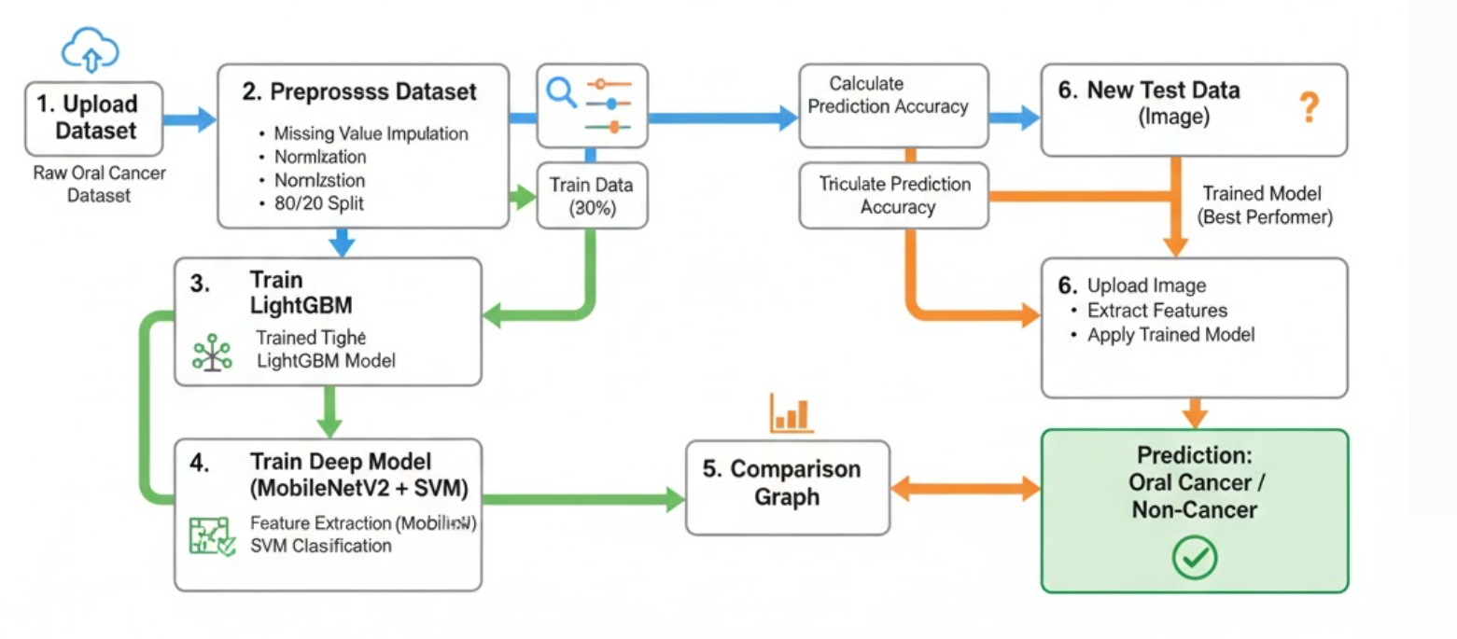
Modules Description:
To implement this project, we have designed following modules
- Upload Dataset: Using this module we will upload our Oral cancer Dataset to application and then application read all the files in the dataset.
- Preprocess Dataset: Using this module we will replace missing values and normalize the extracted features and then split dataset into train and test where application used 80% dataset for training and 20% for testing.
- TrainLightGBM: using this module we will train TrainLightGBM with processed train data and then apply trained model on 20% test data to calculate prediction accuracy.
- Train Deep Model (MobileNetV2 + SVM): using this module we will train Train Deep Model (MobileNetV2 + SVM) with processed train data and then apply trained model on 20% test data to calculate prediction accuracy.
- Comparison Graph: using this module we will plot comparison graph between all models.
- Predict: using this module we will upload test data and then extract features and then apply trained model on extracted features to predict weather test data images have oral cancer or non cancer.

SDLC (Umbrella Model):
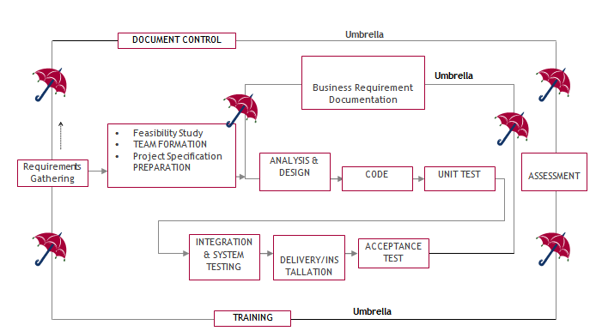

SDLC is nothing but Software Development Life Cycle. It is a standard which is used by software industry to develop good software.

Stages in SDLC:
- Requirement Gathering
- Analysis
- Designing
- Coding
- Testing
- Maintenance

Requirements Gathering stage:
The requirements gathering process takes as its input the goals identified in the high-level requirements section of the project plan. Each goal will be refined into a set of one or more requirements. These requirements define the major functions of the intended application, define operational data areas and reference data areas, and define the initial data entities. Major functions include critical processes to be managed, as well as mission critical inputs, outputs and reports. A user class hierarchy is developed and associated with these major functions, data areas, and data entities. Each of these definitions is termed a Requirement. Requirements are identified by unique requirement identifiers and, at minimum, contain a requirement title and textual description.
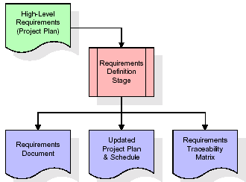
These requirements are fully described in the primary deliverables for this stage: the Requirements Document and the Requirements Traceability Matrix (RTM). The requirements document contains complete descriptions of each requirement, including diagrams and references to external documents as necessary. Note that detailed listings of database tables and fields are not included in the requirements document.
The title of each requirement is also placed into the first version of the RTM, along with the title of each goal from the project plan. The purpose of the RTM is to show that the product components developed during each stage of the software development lifecycle are formally connected to the components developed in prior stages.
In the requirements stage, the RTM consists of a list of high-level requirements, or goals, by title, with a listing of associated requirements for each goal, listed by requirement title. In this hierarchical listing, the RTM shows that each requirement developed during this stage is formally linked to a specific product goal. In this format, each requirement can be traced to a specific product goal, hence the term requirements traceability.
The outputs of the requirements definition stage include the requirements document, the RTM, and an updated project plan.
- Feasibility study is all about identification of problems in a project.
- No. of staff required to handle a project is represented as Team Formation, in this case only modules are individual tasks will be assigned to employees who are working for that project.
- Project Specifications are all about representing of various possible inputs submitting to the server and corresponding outputs along with reports maintained by administrator.

Analysis Stage:
The planning stage establishes a bird's eye view of the intended software product, and uses this to establish the basic project structure, evaluate feasibility and risks associated with the project, and describe appropriate management and technical approaches.
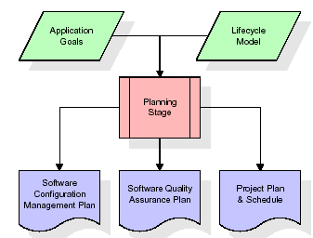
The most critical section of the project plan is a listing of high-level product requirements, also referred to as goals. All of the software product requirements to be developed during the requirements definition stage flow from one or more of these goals. The minimum information for each goal consists of a title and textual description, although additional information and references to external documents may be included. The outputs of the project planning stage are the configuration management plan, the quality assurance plan, and the project plan and schedule, with a detailed listing of scheduled activities for the upcoming Requirements stage, and high level estimates of effort for the out stages.

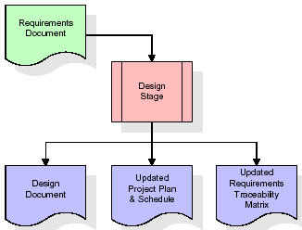
Designing Stage:
The design stage takes as its initial input the requirements identified in the approved requirements document. For each requirement, a set of one or more design elements will be produced as a result of interviews, workshops, and/or prototype efforts. Design elements describe the desired software features in detail, and generally include functional hierarchy diagrams, screen layout diagrams, tables of business rules, business process diagrams, pseudo code, and a complete entity-relationship diagram with a full data dictionary. These design elements are intended to describe the software in sufficient detail that skilled programmers may develop the software with minimal additional input.
When the design document is finalized and accepted, the RTM is updated to show that each design element is formally associated with a specific requirement. The outputs of the design stage are the design document, an updated RTM, and an updated project plan.
Development (Coding) Stage:
The development stage takes as its primary input the design elements described in the approved design document. For each design element, a set of one or more software artifacts will be produced. Software artifacts include but are not limited to menus, dialogs, and data management forms, data reporting formats, and specialized procedures and functions. Appropriate test cases will be developed for each set of functionally related software artifacts, and an online help system will be developed to guide users in their interactions with the software.
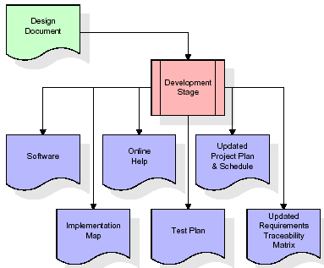

The RTM will be updated to show that each developed artifact is linked to a specific design element, and that each developed artifact has one or more corresponding test case items. At this point, the RTM is in its final configuration. The outputs of the development stage include a fully functional set of software that satisfies the requirements and design elements previously documented, an online help system that describes the operation of the software, an implementation map that identifies the primary code entry points for all major system functions, a test plan that describes the test cases to be used to validate the correctness and completeness of the software, an updated RTM, and an updated project plan.
Integration & Test Stage:
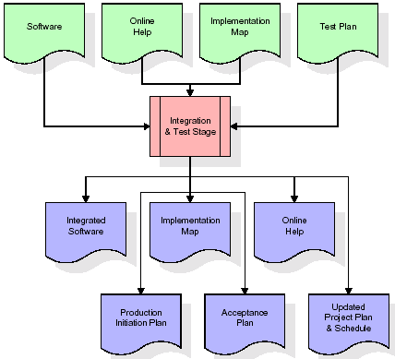
During the integration and test stage, the software artifacts, online help, and test data are migrated from the development environment to a separate test environment. At this point, all test cases are run to verify the correctness and completeness of the software. Successful execution of the test suite confirms a robust and complete migration capability. During this stage, reference data is finalized for production use and production users are identified and linked to their appropriate roles. The final reference data (or links to reference data source files) and production user list are compiled into the Production Initiation Plan.

The outputs of the integration and test stage include an integrated set of software, an online help system, an implementation map, a production initiation plan that describes reference data and production users, an acceptance plan which contains the final suite of test cases, and an updated project plan.
- Installation & Acceptance Test:
During the installation and acceptance stage, the software artifacts, online help, and initial production data are loaded onto the production server. At this point, all test cases are run to verify the correctness and completeness of the software. Successful execution of the test suite is a prerequisite to acceptance of the software by the customer.
After customer personnel have verified that the initial production data load is correct and the test suite has been executed with satisfactory results, the customer formally accepts the delivery of the software.
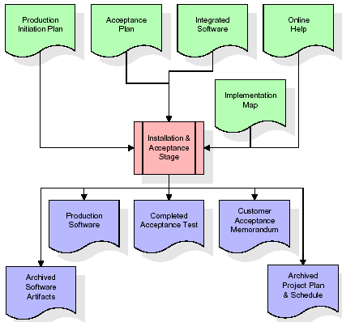
The primary outputs of the installation and acceptance stage include a production application, a completed acceptance test suite, and a memorandum of customer acceptance of the software. Finally, the PDR enters the last of the actual labor data into the project schedule and locks the project as a permanent project record. At this point the PDR "locks" the project by archiving all software items, the implementation map, the source code, and the documentation for future reference.
Maintenance:
Outer rectangle represents maintenance of a project, Maintenance team will start with requirement study, understanding of documentation later employees will be assigned work and they will undergo training on that particular assigned category. For this life cycle there is no end, it will be continued so on like an umbrella (no ending point to umbrella sticks).

3.4. Software Requirement Specification
3.4.1. Overall Description
A Software Requirements Specification (SRS) – a requirements specification for a software system is a complete description of the behaviour of a system to be developed. It includes a set of use cases that describe all the interactions the users will have with the software. In addition to use cases, the SRS also contains non-functional requirements. Non-functional requirements are requirements which impose constraints on the design or implementation (such as performance engineering requirements, quality standards, or design constraints).
System requirements specification: A structured collection of information that embodies the requirements of a system. A business analyst, sometimes titled system analyst, is responsible for analysing the business needs of their clients and stakeholders to help identify business problems and propose solutions. Within the systems development lifecycle domain, the BA typically performs a liaison function between the business side of an enterprise and the information technology department or external service providers. Projects are subject to three sorts of requirements:
- Business requirements describe in business terms what must be delivered or accomplished to provide value.
- Product requirements describe properties of a system or product (which could be one of several ways to accomplish a set of business requirements.)
- Process requirements describe activities performed by the developing organization. For instance, process requirements could specify .Preliminary investigation examine project feasibility, the likelihood the system will be useful to the organization. The main objective of the feasibility study is to test the Technical, Operational and Economical feasibility for adding new modules and debugging old running system. All system is feasible if they are unlimited resources and infinite time. There are aspects in the feasibility study portion of the preliminary investigation:
- ECONOMIC FEASIBILITY
A system can be developed technically and that will be used if installed must still be a good investment for the organization. In the economic feasibility, the development cost in creating the system is evaluated against the ultimate benefit derived from the new systems. Financial benefits must equal or exceed the costs. The system is economically feasible. It does not require any addition hardware or software. Since the interface for this system is developed using the existing resources and technologies available at NIC, there is nominal expenditure and economical feasibility for certain.
- Operational Feasibility
Proposed projects are beneficial only if they can be turned out into information system. That will meet the organization’s operating requirements. Operational feasibility aspects of the project are to be taken as an important part of the project implementation. This system is targeted to be in accordance with the above-mentioned issues. Beforehand, the management issues and user requirements have been taken into consideration. So there is no question of resistance from the users that can undermine the possible application benefits. The well-planned design would ensure the optimal utilization of the computer resources and would help in the improvement of performance status.
- TECHNICAL FEASIBILITY
Earlier no system existed to cater to the needs of ‘Secure Infrastructure Implementation System’. The current system developed is technically feasible. It is a web-based user interface for audit workflow at NIC-CSD. Thus, it provides an easy access to. the users. The database’s purpose is to create, establish and maintain a workflow among various entities in order to facilitate all concerned users in their various capacities or roles. Permission to the users would be granted based on the roles specified. Therefore, it provides the technical guarantee of accuracy, reliability and security.

3.4.2. External Interface Requirements
User Interface
The user interface of this system is a user friendly python Graphical User Interface.
Hardware Interfaces
The interaction between the user and the console is achieved through python capabilities.
Software Interfaces
The required software is python.

SYSTEM REQUIREMENT:
HARDWARE REQUIREMENTS:
- Processor - Intel I3 (min)
- Speed - 1.1 GHz
- RAM - 4GB (min)
- Hard Disk - 500GB (min)
SOFTWARE REQUIREMENTS:
- Operating System - Windows 10/above
- Programming Language - Python 3.7.0 with Jupyter Notebook

4. SYSTEM DESIGN
UML Diagram:
The Unified Modelling Language allows the software engineer to express an analysis model using the modelling notation that is governed by a set of syntactic semantic and pragmatic rules.
A UML system is represented using five different views that describe the system from distinctly different perspective. Each view is defined by a set of diagram, which is as follows.
  - User Model View
    - This view represents the system from the users perspective.
    - The analysis representation describes a usage scenario from the end-users perspective.
  - Structural Model view
    - In this model the data and functionality are arrived from inside the system.
    - This model view models the static structures.
- Behavioural Model View
It represents the dynamic of behavioural as parts of the system, depicting the interactions of collection between various structural elements described in the user model and structural model view.

- Implementation Model View
In this the structural and behavioural as parts of the system are represented as they are to be built.
- Environmental Model View
In this the structural and behavioural aspects of the environment in which the system is to be implemented are represented.
Class Diagram:
The class diagram is the main building block of object oriented modeling. It is used both for general conceptual modeling of the systematic of the application, and for detailed modeling translating the models into programming code. Class diagrams can also be used for data modeling. The classes in a class diagram represent both the main objects, interactions in the application and the classes to be programmed. In the diagram, classes are represented with boxes which contain three parts:
- The upper part holds the name of the class
- The middle part contains the attributes of the class
- The bottom part gives the methods or operations the class can take or undertake.

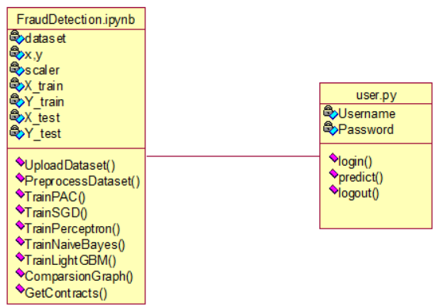
Use case Diagram:
A use case diagram at its simplest is a representation of a user's interaction with the system and depicting the specifications of a use case. A use case diagram can portray the different types of users of a system and the various ways that they interact with the system. This type of
diagram is typically used in conjunction with the textual use case and will often be accompanied by other types of diagrams as well.

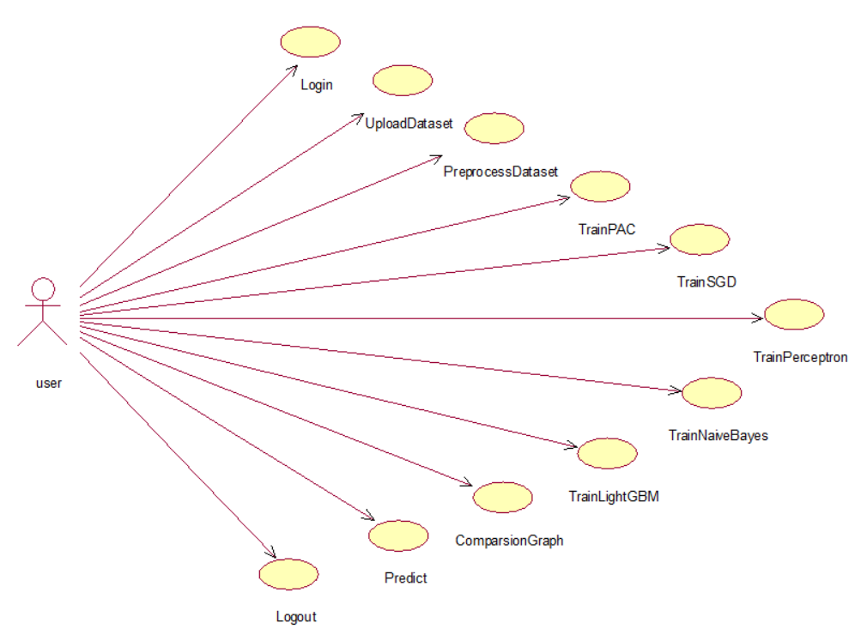
Sequence diagram:
A sequence diagram is a kind of interaction diagram that shows how processes operate with one another and in what order. It is a construct of a Message Sequence Chart. A sequence diagram shows object interactions arranged in time sequence. It depicts the objects and classes involved in the scenario and the sequence of messages exchanged between the objects needed to carry out the functionality of the scenario. Sequence diagrams are typically associated with use case realizations in the Logical View of the system under development. Sequence diagrams are sometimes called event diagrams, event scenarios, and timing diagrams.
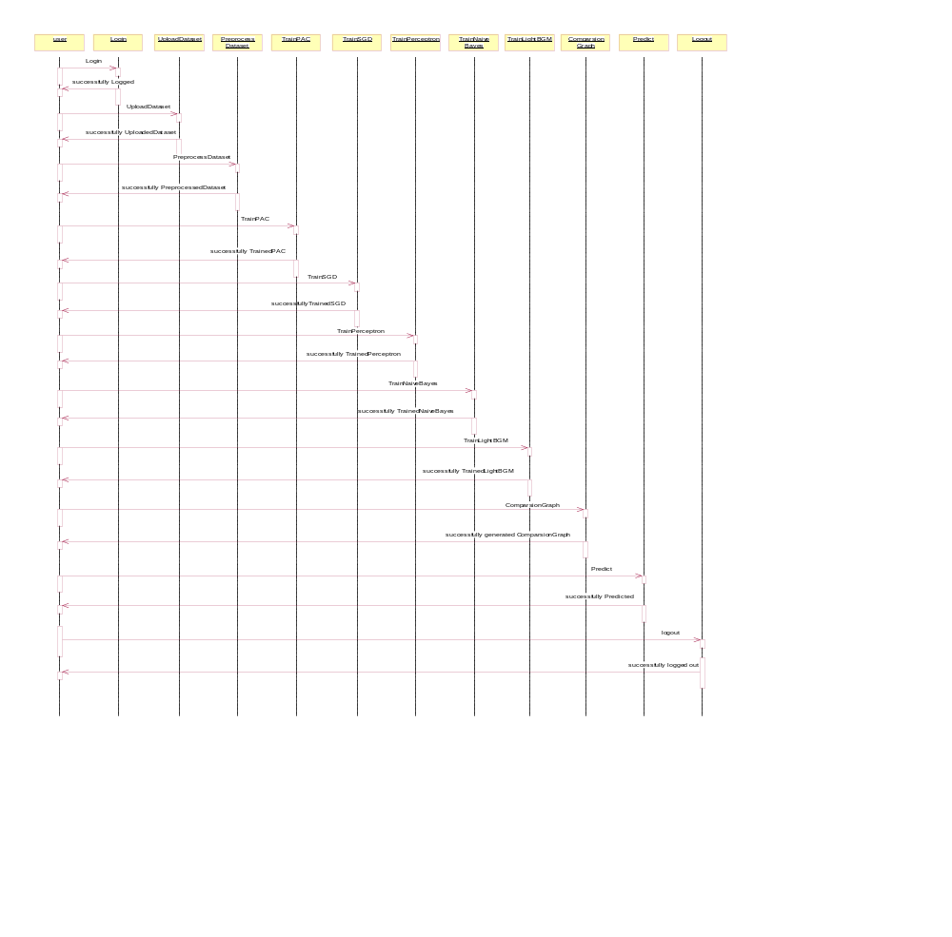
Collaboration diagram:
A collaboration diagram describes interactions among objects in terms of sequenced messages. Collaboration diagrams represent a combination of information taken from class, sequence, and use case diagrams describing both the static structure and dynamic behaviour of a system.
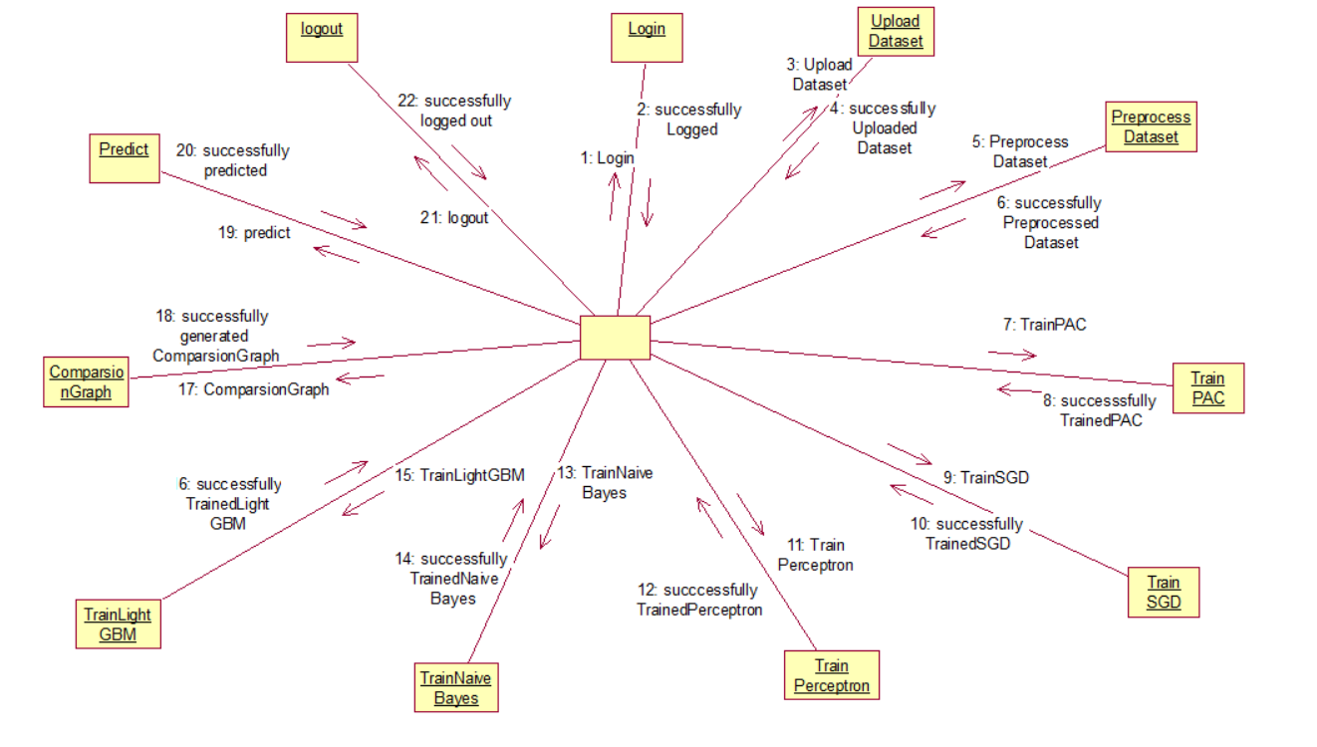
Component Diagram:
In the Unified Modelling Language, a component diagram depicts how components are wired together to form larger components and or software systems. They are used to illustrate the structure of arbitrarily complex systems.
Components are wired together by using an assembly connector to connect the required interface of one component with the provided interface of another component. This illustrates the service consumer - service provider relationship between the two components.

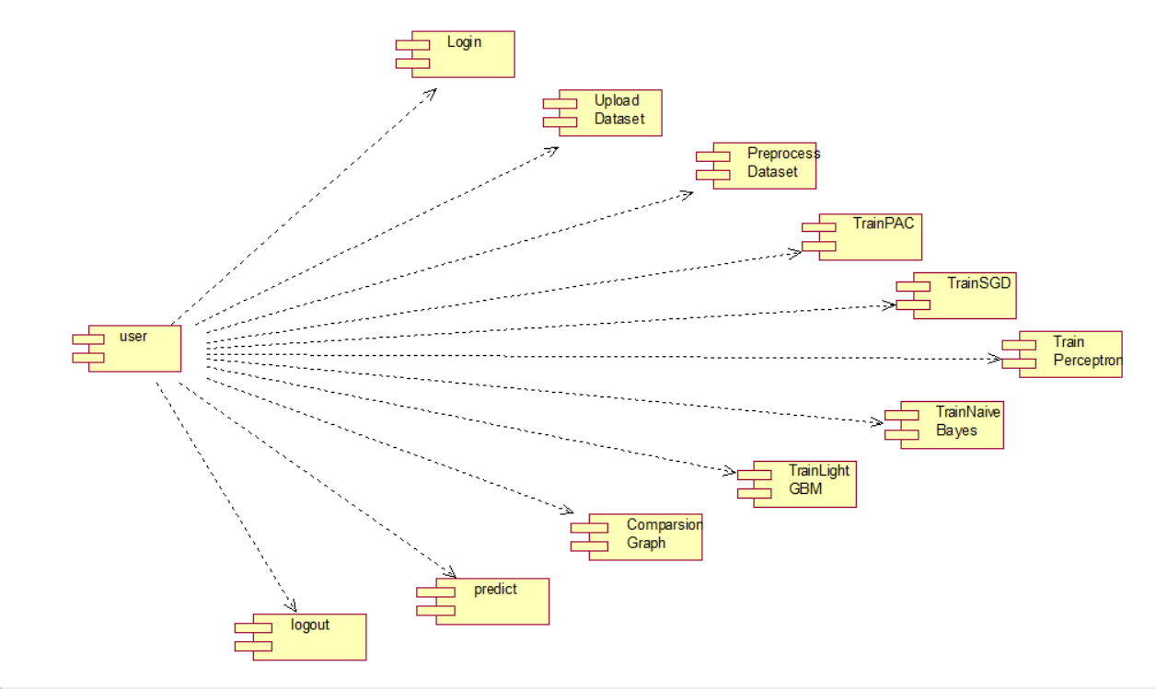
Deployment Diagram:
A deployment diagram in the Unified Modelling Language models the physical deployment of artifacts on nodes. To describe a web site, for example, a deployment diagram would show what hardware components ("nodes") exist (e.g., a web server, an application server, and a database server), what software components ("artifacts") run on each node (e.g., web application, database), and how the different pieces are connected (e.g. JDBC, REST, RMI).
The nodes appear as boxes, and the artifacts allocated to each node appear as rectangles within the boxes. Nodes may have sub nodes, which appear as nested boxes. A single node in a deployment diagram may conceptually represent multiple physical nodes, such as a cluster of database servers.

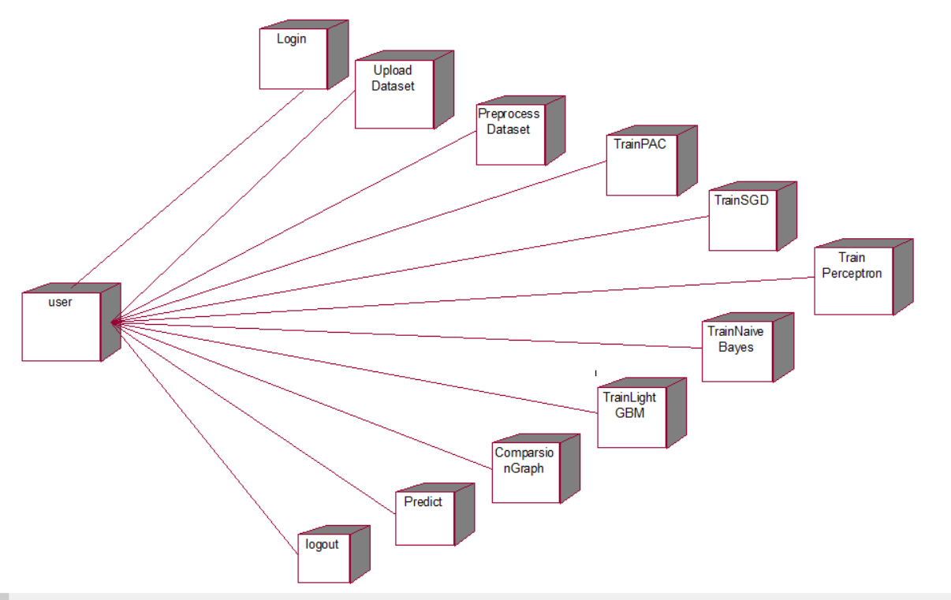
Activity Diagram:
Activity diagram is another important diagram in UML to describe dynamic aspects of the system. It is basically a flow chart to represent the flow form one activity to another
activity. The activity can be described as an operation of the system. So the control flow is drawn from one operation to another. This flow can be sequential, branched or concurrent
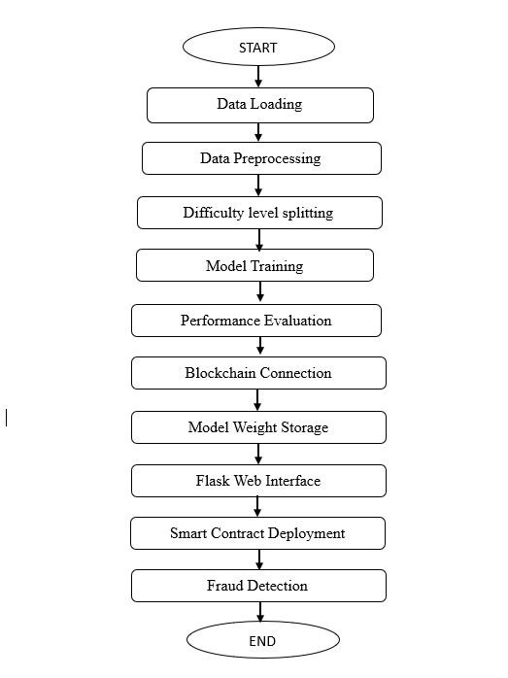

Data Flow Diagram:
Data flow diagrams illustrate how data is processed by a system in terms of inputs and outputs. Data flow diagrams can be used to provide a clear representation of any business function. The technique starts with an overall picture of the business and continues by analyzing each of the functional areas of interest. This analysis can be carried out in precisely the level of detail required. The technique exploits a method called top-down expansion to conduct the analysis in a targeted way.
As the name suggests, Data Flow Diagram (DFD) is an illustration that explicates the passage of information in a process. A DFD can be easily drawn using simple symbols. Additionally, complicated processes can be easily automated by creating DFDs using easy-to-use, free downloadable diagramming tools. A DFD is a model for constructing and analyzing information processes. DFD illustrates the flow of information in a process depending upon the inputs and outputs. A DFD can also be referred to as a Process Model. A DFD demonstrates business or technical process with the support of the outside data saved, plus the data flowing from the process to another and the end results.

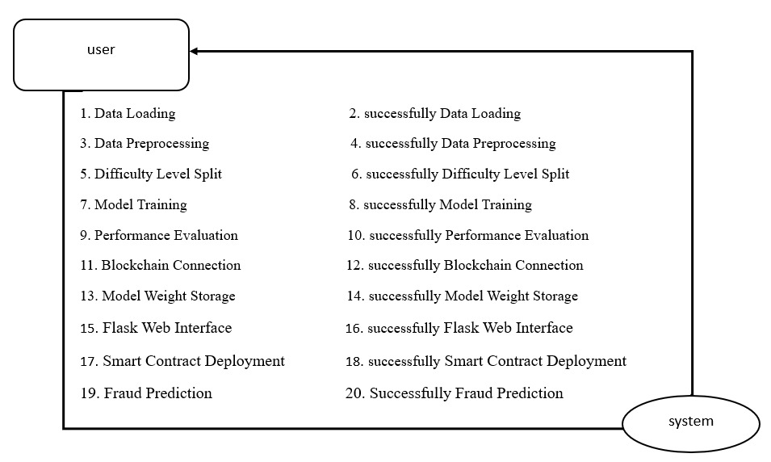

5. IMPLEMETATION
5.1 PYTHON
* One of the most popular languages is Python. Guido van Rossum released this language in 1991. Python is available on the Mac, Windows, and Raspberry Pi operating systems. The syntax of Python is simple and identical to that of English. When compared to Python, it was seen that the other language requires a few extra lines.
*It is an interpreter-based language because code may be run line by line after it has been written. This implies that rapid prototyping is possible across all platforms. Python is a big language with a free, binary-distributed interpreter standard library.
* It is inferior to maintenance that is conducted and is straightforward to learn. It is an object-oriented, interpreted programming language. It supports several different programming paradigms in addition to object-oriented programming, including functional and procedural programming.
* It supports several different programming paradigms in addition to object-oriented programming, including practical and procedural programming. Python is mighty while maintaining a relatively straightforward syntax. Classes, highly dynamic data types, modules, and exceptions are covered. Python can also be utilised by programmes that require programmable interfaces as an external language.
Here are some key features and characteristics of Python:
- Readability: Python emphasizes code readability with its clean and intuitive syntax. It uses indentation and whitespace to structure code blocks, making it easy to understand and maintain.
- Easy to Learn: Python's simplicity and readability make it an excellent choice for beginners. Its straightforward syntax and extensive documentation make it accessible for newcomers to programming.
- Interpreted Language: Python is an interpreted language, meaning that it doesn't need to be compiled before running. The Python interpreter reads and executes the code directly, making the development process faster and more interactive.
- Cross-platform Compatibility: Python is available for major operating systems like Windows, macOS, and Linux. This cross-platform compatibility allows developers to write code once and run it on different platforms without modifications.
- Large Standard Library: Python comes with a vast standard library that provides ready-to-use modules and functions for various tasks. It covers areas such as file I/O, networking, regular expressions, databases, and more, saving developers time and effort.
- Extensible and Modular: Python supports modular programming, enabling developers to organize code into reusable modules and packages. Additionally, Python allows integrating modules written in other languages, such as C or C++, providing flexibility and performance optimizations.
- Wide Range of Libraries and Frameworks: Python has a vibrant ecosystem with numerous third-party libraries and frameworks. These libraries, such as NumPy, pandas, TensorFlow, and Django, extend Python's capabilities for specific domains, making it a powerful tool for diverse applications.
- Object-Oriented: Python supports object-oriented programming (OOP) principles, allowing developers to create and work with classes and objects. OOP provides a structured approach to code organization, promoting code reuse and modularity.
- Dynamic Typing: Python is dynamically typed, meaning variable types are determined at runtime. Developers do not need to declare variable types explicitly, which enhances flexibility and simplifies code writing.
5.2 Installation
To install Python on your computer, follow these basic steps:
- Step 1: Visit the Python website Go to the official Python website at https://www.python.org/.
- Step 2: Select the operating system Choose the appropriate installer for your operating system. Python supports Windows, macOS, and various Linux distributions. Make sure to select the correct version that matches your operating system.
- Step 3: Check which version of Python is installed; if the 3.7.0 version is not there, uninstall it through the control panel and
- Step 4: Install Python 3.7.0 using Cmd.
- Step 5: Install the all libraries that required to run the project
- Step 6: Run

5.3 Python Features:
- Easy: Because Python is a more accessible and straightforward language, Python programming is easier to learn.
- Interpreted language: Python is an interpreted language; therefore it can be used to examine the code line by line and provide results.
- Open Source: Python is a free online programming language since it is open-source.
- Portable: Python is portable because the same code may be used on several computer standard
- libraries: Python offers a sizable library that we may utilize to create applications quickly.
- GUI: It stands for GUI (Graphical User Interface)
- Dynamical typed: Python is a dynamically typed language; therefore the type of the value will be determined at runtime.
5.4 Python IDLE
- Python IDLE offers a full-fledged file editor, which gives you the ability to write and execute Python programs from within this program. The built-in file editor also includes several features, like code completion and automatic indentation, that will speed up your coding workflow.
- Guido Van Rossum named Python after the British comedy group Monty Python while the name IDLE was chosen to pay tribute to Eric Idle, who was one of the Monty Python's founding members. IDLE comes bundled with the default implementation of the Python language since the 01.5. 2b1 release
- IDLE is used to execute statements similar to Python Shell. IDLE is used to create, modify, and execute Python code. IDLE provides a fully-featured text editor to write Python scripts and provides features like syntax highlighting, auto-completion, and smart indent.
- IDLE has two modes: interactive and script. We wrote our first program, “Hello, World!” in interactive mode. Interactive mode immediately returns the results of commands you enter into the shell. In script mode, you will write a script and then run it.
- The IDE Python IDLE is a good place to start as it helps you become familiar with the way Python works and understand its syntax. This IDE is good to start programming in Python due to its great debugger, but once you are fluent and start developing projects it is necessary to jump to another, more complete IDE.
- Python IDLE (Integrated Development and Learning Environment) is an interactive development environment included with the Python programming language. It provides a convenient way to write, execute, and debug Python code.
When you install Python, IDLE is typically installed along with it. To open IDLE, you can follow these steps:
- Open the command prompt (Windows) or terminal (macOS/Linux).
- Type "idle" and press Enter. Alternatively, you can specify the version with "idle3" or "idle2" for Python 3 or Python 2, respectively.
- Once IDLE is launched, you will see the Python shell, which is an interactive environment where you can type and execute Python code directly.
Here are some features and functionalities provided by Python IDLE:
- Editor: IDLE includes a text editor where you can write your Python code. It offers syntax highlighting, automatic indentation, and code completion to enhance your coding experience.
- Interactive Shell: The Python shell in IDLE allows you to execute Python code interactively. You can type commands, statements, or function calls directly in the shell, and Python will execute them immediately.
- Debugging: IDLE provides basic debugging capabilities to help you find and fix errors in your code. You can set breakpoints, step through code, inspect variables, and track the program's execution.
- Python Help: IDLE provides access to the Python documentation and built-in help. You can access the help menu to find information about Python modules, functions, classes, and more.
- Script Execution: In addition to the interactive shell, IDLE allows you to run Python scripts stored in files. You can write your code in the editor and execute it as a script to see the output or interact with the program.
- Customization: IDLE can be customized to suit your preferences. You can modify settings related to syntax highlighting, indentation, fonts, and more.
- Python IDLE serves as a beginner-friendly development environment and learning tool. It is suitable for writing small scripts, testing code snippets, experimenting with Python features, and learning the language's basics. However, for more advanced development projects, you may consider using other code editors or integrated development environments (IDEs) that provide additional features and better project management capabilities.
5.5 Libraries
In Python, libraries (also referred to as modules or packages) are collections of pre-written code that provide additional functionality and tools to extend the capabilities of the Python language. Libraries contain reusable code that developers can leverage to perform specific tasks without having to write everything from scratch.
Python libraries are designed to solve common problems, such as handling data, performing mathematical operations, interacting with databases, working with files, implementing networking protocols, creating graphical user interfaces (GUIs), and much more. They provide ready-to-use functions, classes, and methods that simplify complex operations and save development time.
Libraries in Python offer various advantages:
- Code Reusability:
- Efficiency:
- Collaboration
- Domain-Specific Functionality
- To use a Python library, you need to install it first.
There are some libraries following:
- NumPy:
The NumPy Python library for multi-dimensional, big-scale matrices adds a huge number of high-level mathematical functions. It is possible to modify NumPy by utilizing a Python library. Along with line, algebra, and the Fourier transform operations, it also contains several matrices-related functions.
NumPy can be used to perform a wide variety of mathematical operations on arrays. It adds powerful data structures to Python that guarantee efficient calculations with arrays and matrices and it supplies an enormous library of high-level mathematical functions that operate on these arrays and matrices.
- NumPy is a Python library used for working with arrays.
- It also has functions for working in domain of linear algebra, Fourier transform, and matrices.
- NumPy was created in 2005 by Travis Oliphant. It is an open source project and you can use it freely.
- NumPy stands for Numerical Python.
- In Python we have lists that serve the purpose of arrays, but they are slow to process.
- NumPy aims to provide an array object that is up to 50x faster than traditional Python lists.
- The array object in NumPy is called ndarray, it provides a lot of supporting functions that make working with ndarray very easy.
- Arrays are very frequently used in data science, where speed and resources are very important.

- Sklearn:
Scikit-learn (commonly imported as sklearn) is an open-source Python library widely used for machine learning, data mining, and data analysis. It provides simple and efficient tools for performing predictive data analysis and building machine learning models. Scikit-learn is built on top of popular Python libraries such as NumPy, SciPy, and matplotlib.
Key Features of Scikit-learn:
- Supervised Learning Algorithms: Includes regression, classification, and ensemble methods such as Random Forest, Support Vector Machines (SVM), and k-Nearest Neighbors (k-NN).
- Unsupervised Learning Algorithms: Provides clustering and dimensionality reduction methods like K-Means, DBSCAN, PCA, and t-SNE.
- Preprocessing Tools: For scaling, normalization, encoding categorical data, and handling missing values.
- Model Evaluation and Selection: Includes functions for cross-validation, metrics (accuracy, precision, recall, F1-score), and hyperparameter tuning.
- Pipeline Support: Allows chaining preprocessing steps and model training in a single workflow.
- Integration: Works seamlessly with other Python libraries like pandas, NumPy, and matplotlib for data handling and visualization.
- Documentation and Community Support: Well-documented and widely supported by the data science community.
Advantages of Scikit-learn:
- Easy-to-use interface with consistent API across algorithms.
- Supports a wide variety of machine learning algorithms.
- Efficient and optimized for performance on medium-sized datasets.
- Integrates well with Python ecosystem for data science and AI.
- Strong community support with extensive tutorials and examples.
Disadvantages of Scikit-learn:
- Not optimized for deep learning; primarily used for classical ML.
- May struggle with very large datasets or distributed computing.
- Limited support for GPU acceleration (requires integration with libraries like TensorFlow or PyTorch for deep learning).

- Medical imaging and autonomous vehicles

- Matplotlib:
Matplotlib is a popular open-source Python library for data visualization. It allows users to create a wide range of 2D plots and basic 3D visualizations in both interactive and non-interactive environments. Commonly used in data science, machine learning, and research, Matplotlib helps transform raw data into easy-to-understand visual representations such as line graphs, bar charts, scatter plots, pie charts, histograms, and heatmaps. It is often used alongside NumPy and Pandas for analyzing and visualizing datasets, and integrates smoothly with Jupyter Notebooks, making it widely adopted in education, research, and industry.
Features of Matplotlib
- Wide Variety of Plots: Supports line, bar, scatter, histogram, pie, stem, and 3D plots.
- Highly Customizable: Control figure size, axis scales, colors, styles, legends, labels, and annotations.
- Interactive Visualization: Allows zooming, panning, and dynamic updates in Jupyter Notebooks and GUI-based backends.
- Integration with Libraries: Works seamlessly with NumPy, Pandas, SciPy, and scikit-learn for scientific computing and machine learning tasks.
- Export Options: Supports saving plots in multiple formats such as PNG, JPG, SVG, PDF, and EPS.
- Animations: Provides functionality to create simple animations for time-series and dynamic data visualization.
- Cross-Platform Support: Runs on Windows, Linux, and macOS environments.
- Open Source & Active Community: Regularly updated with contributions from a large community of developers and researchers.

Web3:
Web3, also known as Web 3.0, represents the next generation of the internet that emphasizes decentralization, blockchain technology, and user ownership. Unlike the traditional web (Web 2.0), which relies on centralized servers and intermediaries, Web3 aims to create an open and trustless digital ecosystem where users have greater control over their data, identity, and digital assets. It marks a shift from company-driven platforms to user-driven networks.
The concept of Web3 is built primarily on blockchain technology, the same foundation that supports cryptocurrencies such as Bitcoin and Ethereum. Blockchain acts as a distributed ledger that records transactions securely and transparently without the need for centralized authorities. In Web3, this technology is used not only for digital currency transactions but also for applications like decentralized finance (DeFi), non-fungible tokens (NFTs), and decentralized applications (dApps).
One of the key principles of Web3 is decentralization. In Web 2.0, user data is stored on centralized servers owned by corporations like Google, Facebook, or Amazon. In contrast, Web3 applications distribute data across multiple nodes on a blockchain network, ensuring that no single entity has complete control. This reduces censorship, enhances security, and promotes transparency in digital interactions.
Another major feature of Web3 is user ownership and digital identity management. Through cryptographic wallets (such as MetaMask or Phantom), users can manage their own data, assets, and credentials securely. This eliminates the need for third-party authentication systems and allows users to interact directly with decentralized applications. In essence, Web3 empowers individuals to “own” their digital presence instead of being products of centralized platforms.
Web3 also introduces the concept of smart contracts, which are self-executing agreements coded directly on the blockchain. These contracts automatically enforce rules and conditions without intermediaries, enabling trustless transactions. Smart contracts form the backbone of many decentralized applications, including DeFi platforms, NFT marketplaces, and blockchain-based gaming ecosystems.
In addition, Web3 supports tokenization and digital economies through the use of cryptocurrencies and tokens. Tokens serve as units of value that can represent assets, voting rights, or access to services within decentralized networks. This enables new economic models, such as play-to-earn games and decentralized autonomous organizations (DAOs), where community members participate in governance and decision-making.
Despite its advantages, Web3 still faces several challenges. These include scalability issues, energy consumption, complex user interfaces, and regulatory uncertainty. Moreover, transitioning from centralized infrastructures to decentralized systems requires major technological and social adaptations. However, continuous research and innovations, such as Layer 2 scaling solutions and interoperability protocols, are gradually addressing these challenges.
In conclusion, Web3 represents the evolution of the internet toward a more secure, transparent, and user-centric environment. By combining blockchain, decentralization, and cryptographic technologies, it promises to redefine how people interact, share data, and conduct transactions online. Though still in its early stages, Web3 is paving the way for a truly open and democratic digital ecosystem where users are at the center of control and innovation.
Pandas:
Pandas is an open-source Python library designed for data manipulation, analysis, and cleaning. The name “Pandas” is derived from “Panel Data”, which refers to multidimensional structured data sets. It is one of the most essential and widely used libraries in data science, machine learning, and analytics due to its powerful, flexible, and easy-to-use data structures. Pandas provides high-level data manipulation tools that make handling structured data fast and efficient.
At its core, Pandas introduces two main data structures: the Series and the DataFrame. A Series is a one-dimensional labeled array that can hold any type of data such as integers, strings, or floating-point numbers. A DataFrame, on the other hand, is a two-dimensional labeled data structure that resembles a table in a database or an Excel spreadsheet. It consists of rows and columns, where each column can contain different data types. These structures make it easy to store and manipulate large datasets efficiently.
Pandas is particularly useful for data cleaning and preprocessing, which are crucial steps in any data analysis pipeline. It provides built-in functions to handle missing data, filter rows, rename columns, merge datasets, and transform data into different formats. The ability to perform these operations using simple and readable syntax makes Pandas a favorite among data analysts and machine learning practitioners.
One of the major advantages of Pandas is its ability to integrate seamlessly with other Python libraries such as NumPy, Matplotlib, Seaborn, and Scikit-learn. For example, Pandas can easily convert data into NumPy arrays for numerical computations or visualize datasets directly using Matplotlib. This interoperability makes it an essential tool for building complete data analysis and machine learning workflows in Python.
Pandas also provides strong data input and output capabilities. It supports reading and writing data from multiple file formats such as CSV, Excel, JSON, SQL databases, and even HTML tables. This makes it easy to import and export datasets from various sources without complex coding. Its efficient data handling allows users to process millions of records within seconds.
Another important feature of Pandas is its powerful indexing and selection capabilities. Users can access data using labels, positions, or Boolean conditions, enabling fine-grained control over datasets. Functions like loc[] and iloc[] make it easy to select specific rows or columns for analysis. Additionally, Pandas supports grouping and aggregation operations through the groupby() function, allowing users to summarize and analyze data efficiently.
Pandas also excels at time series analysis, which involves working with date and time data. It provides tools for resampling, shifting, and rolling computations that make it ideal for financial and scientific applications where time-based data analysis is required. This functionality has made Pandas popular in domains such as stock market analysis, forecasting, and sensor data monitoring.
The performance and scalability of Pandas have improved over time, with optimizations that make use of NumPy’s efficient array operations under the hood. It can handle large datasets that fit into memory, and for even larger data, it can be integrated with tools like Dask for distributed computing. This ensures that Pandas remains a practical choice for both small-scale and large-scale data projects.
In conclusion, Pandas is a highly versatile library that simplifies complex data operations into easy and readable Python commands. Its combination of data structures, integration capabilities, and powerful functions make it an indispensable tool for data analysis, preprocessing, and visualization. Whether you are performing exploratory data analysis or building a machine learning pipeline, Pandas serves as the backbone for efficient and effective data handling.
Seaborn:
Seaborn is a powerful and easy-to-use Python data visualization library built on top of Matplotlib. It is specifically designed for creating informative, attractive, and statistical graphics that help in understanding data patterns and relationships effectively. Seaborn simplifies the process of generating complex visualizations with just a few lines of code and is widely used in data analysis, data science, and machine learning projects.
The main goal of Seaborn is to make statistical data visualization easier and more visually appealing. It provides high-level functions for drawing common statistical plots such as bar plots, box plots, violin plots, scatter plots, line plots, heatmaps, and pair plots. These visualizations help analysts explore data distributions, detect outliers, and identify correlations between multiple variables.
One of the most significant advantages of Seaborn is its integration with Pandas. It can work directly with Pandas DataFrames and Series, allowing users to visualize data without converting it into separate structures. This makes it extremely convenient for analyzing datasets directly after cleaning or transformation using Pandas. Each plot in Seaborn can be created using simple functions where columns are referenced by their names from the DataFrame.
Seaborn also enhances the visual quality of plots by applying aesthetic themes and color palettes automatically. It offers several built-in themes such as darkgrid, whitegrid, dark, white, and ticks, which improve readability and visual consistency. Additionally, users can customize color palettes to match the context of the analysis, making visualizations more engaging and presentation-ready.
Another core feature of Seaborn is its ability to visualize statistical relationships between multiple variables. Functions like relplot(), pairplot(), and jointplot() make it easy to analyze interactions and correlations between features. For example, pairplot() can automatically generate multiple scatter plots and histograms to explore pairwise relationships among all numerical features in a dataset.
Seaborn also supports categorical data visualization through functions such as countplot(), barplot(), stripplot(), and swarmplot(). These functions allow analysts to summarize and compare data across different categories effectively. For more advanced analysis, violinplot() and boxplot() provide detailed insights into the distribution and variability of numerical data within categories.
One of the most useful and visually rich features of Seaborn is the heatmap, which helps in visualizing data matrices and correlations. The heatmap() function is commonly used to represent correlation matrices in data analysis, where colors indicate the strength and direction of relationships between variables. This helps in feature selection and understanding data dependencies in machine learning.
Seaborn also provides tools for regression analysis and trend visualization. With functions like lmplot() and regplot(), users can easily add regression lines to scatter plots, allowing them to observe trends and relationships between dependent and independent variables. This makes it a valuable tool for exploratory data analysis (EDA) and model understanding.
In addition to its simplicity and aesthetics, Seaborn is highly customizable. It allows fine-tuning of every aspect of a plot — including titles, labels, legend positions, and scales — ensuring professional-quality results suitable for research papers and presentations. Moreover, Seaborn works seamlessly with Matplotlib, so users can combine the flexibility of Matplotlib with the elegance of Seaborn.
In conclusion, Seaborn is an essential Python library for creating visually appealing and meaningful statistical graphics. Its tight integration with Pandas, built-in aesthetic features, and ability to generate complex plots effortlessly make it a preferred tool for data visualization in modern data science workflows. Whether you are performing exploratory data analysis or presenting insights, Seaborn helps turn raw data into clear and impactful visual stories.

Algorithms:
- LightGBM:
LightGBM (Light Gradient Boosting Machine) is a high-performance, open-source machine learning framework developed by Microsoft, designed for fast and efficient gradient boosting. It is based on the principle of Gradient Boosting Decision Trees (GBDT), where models are built in a sequential manner, and each new tree corrects the errors made by the previous ones.
Unlike traditional GBDT implementations, LightGBM uses leaf-wise tree growth instead of level-wise growth, allowing the model to grow deeper trees in areas where they are most useful. This results in higher accuracy and faster training time, especially with large datasets. It also supports histogram-based algorithms, reducing memory usage and improving speed over traditional decision tree learning.
LightGBM is widely used in classification, regression, ranking, and feature selection tasks. It supports GPU acceleration, handles large-scale data efficiently, and works well with sparse data. Due to its high speed and performance, LightGBM has become a preferred model in data science competitions like Kaggle.

Advantages:
- Faster training speed compared to XGBoost and Random Forest
- Lower memory consumption through histogram-based learning
- Better accuracy due to leaf-wise tree growth
- Automatically handles missing values
- Supports categorical feature handling without one-hot encoding
- Scalable to very large datasets
Applications:
- Credit risk scoring and fraud detection
- Medical diagnosis and predictive healthcare systems
- Customer churn prediction
- Stock market prediction and time-series modeling
- Recommendation engines
- Real-time ranking systems (e.g., search engines, ads)

Passive Aggressive Classifier (PAC):
The Passive Aggressive Classifier (PAC) is an online learning algorithm widely used for large-scale and streaming data classification tasks. It belongs to the family of linear classifiers and is designed to update its model parameters efficiently whenever a new training instance becomes available. Unlike traditional batch learning methods that retrain the entire model with all data, PAC updates itself incrementally, making it suitable for real-time applications.
The term “Passive-Aggressive” reflects the unique behavior of the algorithm during training. The classifier acts passively when it correctly classifies an instance — meaning it makes no change to the model. However, when it misclassifies an instance or the prediction is incorrect beyond a certain tolerance, it becomes aggressive, immediately updating its parameters to correct the error. This balance between passivity and aggressiveness allows the model to adapt quickly without overreacting to noise.
Mathematically, the Passive Aggressive algorithm aims to minimize a hinge loss function, similar to Support Vector Machines (SVMs). For each misclassified example, it adjusts the weight vector www in a way that the new example is correctly classified while keeping the model update as small as possible. The objective is to maintain both high accuracy and model stability over time.
There are mainly three variants of the algorithm: PA, PA-I, and PA-II. The basic PA model performs updates without any regularization, while PA-I and PA-II include regularization terms that control the aggressiveness of the update. These variations help prevent overfitting and allow the model to perform better on noisy datasets.
One of the main advantages of the Passive Aggressive Classifier is its speed and scalability. Since it processes one example at a time and updates instantly, it can handle large datasets and streaming data efficiently. This makes it a preferred choice for real-time classification tasks such as spam detection, sentiment analysis, news categorization, and online recommendation systems.
The PAC works effectively for binary and multiclass classification problems. It uses a linear decision boundary to separate the classes, and its performance depends largely on the quality of the feature representation. The model can be easily implemented using machine learning libraries like scikit-learn, where it provides an efficient alternative to algorithms like SVMs and logistic regression for online settings.
In terms of performance, the Passive Aggressive Classifier is known for its fast convergence and robustness to outliers. It quickly adapts to new patterns in data streams without requiring full retraining. However, it may perform suboptimally on highly non-linear data unless combined with feature transformations or kernel tricks.
Stochastic Gradient Descent (SGD):
Stochastic Gradient Descent (SGD) is one of the most widely used optimization algorithms in machine learning and deep learning. It is a variant of the traditional Gradient Descent method, designed to efficiently minimize the loss function of a model by iteratively adjusting its parameters. The main goal of SGD is to find the optimal set of weights that minimize the prediction error of a learning model.
In the standard Gradient Descent approach, the algorithm computes the gradient of the loss function using the entire training dataset before updating the model parameters. While this method ensures accurate gradient estimation, it becomes computationally expensive and slow, especially for large datasets. To overcome this limitation, SGD updates the model parameters using only a single training example (or a small batch) at a time, making it faster and more suitable for large-scale and online learning applications.
The term “stochastic” refers to the random nature of the algorithm. Instead of calculating gradients deterministically using the whole dataset, SGD introduces randomness by selecting a random sample in each iteration. This randomness allows the algorithm to escape local minima and improves generalization performance, though it also introduces noise into the optimization process.
Mathematically, the update rule in SGD is expressed as:
θ=θ−η⋅∇θL(xi,yi)\theta = \theta - \eta \cdot \nabla_\theta L(x_i, y_i)θ=θ−η⋅∇θ​L(xi​,yi​)
where θ\thetaθ represents the model parameters, η\etaη is the learning rate, and ∇θL(xi,yi)\nabla_\theta L(x_i, y_i)∇θ​L(xi​,yi​) is the gradient of the loss function with respect to a single training sample (xi,yi)(x_i, y_i)(xi​,yi​). The learning rate controls how large a step the algorithm takes in the direction of the negative gradient.
One of the major advantages of SGD is its computational efficiency. Since it updates parameters more frequently, it can start improving the model much earlier than batch gradient descent. This makes it ideal for training neural networks and other models that deal with massive amounts of data. However, due to its noisy updates, the loss function does not decrease smoothly but rather fluctuates around the minimum.
To stabilize the learning process, various improvements of SGD have been introduced, such as SGD with Momentum, Nesterov Accelerated Gradient (NAG), and adaptive methods like Adam and RMSProp. Momentum helps accelerate convergence by adding a fraction of the previous gradient update, while NAG anticipates future steps to make more informed updates. These modifications make SGD more robust and faster in practice.
SGD is commonly used in both linear models (like logistic regression and SVMs) and deep learning architectures (such as CNNs and RNNs). It plays a vital role in minimizing the loss during backpropagation in neural networks. Due to its ability to handle large datasets and continuously update parameters, SGD is also preferred for online learning scenarios where new data arrives in real time.
In conclusion, Stochastic Gradient Descent is a foundational optimization technique that powers most modern machine learning algorithms. Its simplicity, scalability, and adaptability to large datasets make it an essential component of model training, helping machines learn efficiently from data while maintaining computational feasibility.
Perceptron:
The Perceptron is one of the earliest and most fundamental algorithms in machine learning, introduced by Frank Rosenblatt in 1958. It is a type of supervised learning algorithm used for binary classification, meaning it determines whether an input belongs to one class or another. The perceptron is considered the foundation of modern neural networks and serves as a basic model of how artificial neurons work.
Conceptually, the perceptron simulates the behavior of a biological neuron. It takes multiple input features, applies weights to them, sums the weighted inputs, and passes the result through an activation function to produce an output. The model learns by adjusting its weights based on the error between predicted and actual outputs during the training process. This learning process allows the perceptron to improve its accuracy over time.
Mathematically, the perceptron computes the following function:
y=f(w⋅x+b)y = f(w \cdot x + b)y=f(w⋅x+b)
where xxx represents the input vector, www represents the weights, bbb is the bias term, and fff is the activation function—usually a step function. If the weighted sum of inputs is greater than a certain threshold, the perceptron outputs one class (e.g., +1); otherwise, it outputs the other class (e.g., -1). This simple decision rule helps in linearly separating the data.
The perceptron uses an iterative learning rule to update its weights during training. The update rule is given by:
wnew=wold+η(ytrue−ypred)xw_{new} = w_{old} + \eta (y_{true} - y_{pred})xwnew​=wold​+η(ytrue​−ypred​)x
where η\etaη is the learning rate, ytruey_{true}ytrue​ is the actual label, and ypredy_{pred}ypred​ is the predicted output. The weights are adjusted only when a misclassification occurs, ensuring the model gradually converges to a correct decision boundary.
One of the major strengths of the perceptron is its simplicity and interpretability. It provides an intuitive understanding of how classification models learn to distinguish between two categories. However, its main limitation is that it can only classify linearly separable data. This means that if the data cannot be divided by a straight line (or hyperplane in higher dimensions), the perceptron fails to achieve accurate results.
Despite this limitation, the perceptron laid the groundwork for more advanced neural network models such as Multi-Layer Perceptrons (MLPs) and Deep Neural Networks (DNNs). These extended models overcome the linearity restriction by using multiple layers of neurons and nonlinear activation functions, enabling them to learn complex patterns in data.
The perceptron is widely used in educational and research contexts as a starting point for understanding neural network concepts. It is also applied in basic pattern recognition problems, such as image classification, speech recognition, and signal processing, where linear separability holds true.
In conclusion, the Perceptron is a simple yet powerful algorithm that represents the historical beginning of artificial neural networks. Though limited in its capacity to handle complex datasets, it remains an essential concept for understanding how modern deep learning models evolve and operate.
Naïve Bayes Classifier:
The Naïve Bayes Classifier is a simple yet powerful probabilistic machine learning algorithm based on Bayes’ Theorem. It is primarily used for classification tasks, where the goal is to predict the category of a given input based on prior data. Despite its simplicity, Naïve Bayes often performs remarkably well, especially in text classification problems such as spam detection, sentiment analysis, and document categorization.
At its core, Naïve Bayes relies on Bayes’ Theorem, which provides a mathematical way to calculate the probability of a class given certain features. Bayes’ Theorem is expressed as:
P(C∣X)=P(X∣C)⋅P(C)P(X)P(C|X) = \frac{P(X|C) \cdot P(C)}{P(X)}P(C∣X)=P(X)P(X∣C)⋅P(C)​
Here, P(C∣X)P(C|X)P(C∣X) represents the posterior probability of class CCC given the feature set XXX; P(X∣C)P(X|C)P(X∣C) is the likelihood of the features occurring within class CCC; P(C)P(C)P(C) is the prior probability of the class; and P(X)P(X)P(X) is the evidence or overall probability of the features.
The algorithm is called “Naïve” because it assumes that all features in the dataset are independent of each other given the class label. In real-world data, this assumption is rarely true, but the simplification allows the model to calculate probabilities efficiently and perform surprisingly well even when the assumption is violated. This independence assumption makes the model fast, easy to implement, and effective for high-dimensional datasets.
The working of Naïve Bayes involves two main steps: training and prediction. During training, the model learns the prior probability of each class and the likelihood of each feature occurring within those classes. During prediction, it calculates the posterior probability for each class given a new input and assigns the input to the class with the highest probability. This makes Naïve Bayes a maximum a posteriori (MAP) classifier.
There are several variants of the Naïve Bayes algorithm, each designed for different types of data. The most common types are:
- Gaussian Naïve Bayes, used when features are continuous and follow a normal distribution.
- Multinomial Naïve Bayes, suitable for discrete features such as word counts in text classification.
- Bernoulli Naïve Bayes, used when features are binary (e.g., presence or absence of a word).
One of the main advantages of the Naïve Bayes Classifier is its speed and efficiency. It requires very little training data to estimate parameters and is highly scalable for large datasets. Moreover, it performs particularly well in real-time applications like email spam filtering, news categorization, and sentiment analysis.
However, Naïve Bayes also has limitations. Its assumption of feature independence can sometimes lead to suboptimal performance when the input variables are highly correlated. Additionally, it may struggle with zero-frequency problems, where unseen features in the test set lead to zero probability values. This issue is commonly addressed using Laplace Smoothing, which ensures no probability becomes exactly zero.
In conclusion, the Naïve Bayes Classifier remains one of the most practical and efficient algorithms for classification tasks. Its foundation in probability theory, combined with its simplicity and effectiveness, makes it a strong baseline model in machine learning and a preferred choice for many text-based and real-time applications.

5.2 Sample Code:
FraudDetection.ipynb
#import required classes and packages
from lightgbm import LGBMClassifier
from web3 import Web3, HTTPProvider
import json
from imblearn.over_sampling import SMOTE
from sklearn.linear_model import SGDClassifier
from sklearn.linear_model import PassiveAggressiveClassifier
import pandas as pd #pandas to read and explore dataset
import numpy as np
from sklearn.preprocessing import StandardScaler
from sklearn.preprocessing import LabelEncoder
from sklearn.model_selection import train_test_split
from sklearn.metrics import accuracy_score
import timeit
from sklearn.linear_model import Perceptron
from sklearn.naive_bayes import BernoulliNB
from sklearn.naive_bayes import MultinomialNB
from sklearn.metrics import precision_score
from sklearn.metrics import recall_score
from sklearn.metrics import f1_score
from sklearn.metrics import confusion_matrix
import seaborn as sns
import matplotlib.pyplot as plt
#function to initialize Blockchain contract to save and get local models
def getContract():
blockchain_address = 'http://127.0.0.1:9545'
web3 = Web3(HTTPProvider(blockchain_address))
web3.eth.defaultAccount = web3.eth.accounts[0]
compiled_contract_path = 'MLContract.json' #Smart Contract to manage ML model weights
deployed_contract_address = '0xd374Cb05bd6187D6cF905D7bBD85f2b704fBDD29' #contract address
with open(compiled_contract_path) as file:
contract_json = json.load(file) # load contract info as JSON
contract_abi = contract_json['abi'] # fetch contract's abi - necessary to call its functions
file.close()
contract = web3.eth.contract(address=deployed_contract_address, abi=contract_abi)
return contract, web3
contract, web3 = getContract()
print("Blockchain Contract Deployment & Connection Successful")
#function to get list of weights from Blockchain for all clients
def getWeightList():
global contract
weightList = []
count = contract.functions.getModelCount().call()
for i in range(0, count):
model_name = contract.functions.getClientName(i).call()
model_weight = contract.functions.getWeight(i).call()
model_intercept = contract.functions.getHash(i).call()
model_classes = contract.functions.getDate(i).call()
weightList.append([model_name, model_weight, model_intercept, model_intercept])
return weightList
weightList = getWeightList()
print("Blockchain Model Weight List Initialized")
#loading and displaying IoT23 attack dataset
dataset = pd.read_csv("Dataset/data.csv")
dataset
#visualizing different attack class labels count found in dataset
names, count = np.unique(dataset['isFraud'], return_counts = True)
labels = ['Normal', 'Fraud']
height = count
bars = labels
y_pos = np.arange(len(bars))
plt.figure(figsize = (5, 3))
plt.bar(y_pos, height)
plt.xticks(y_pos, bars)
plt.xlabel("Dataset Class Label Graph")
plt.ylabel("Count")
plt.show()
#applying dataset processing technique to convert non-numeric data to numeric data
label_encoder = []
columns = dataset.columns
types = dataset.dtypes.values
for j in range(len(types)):
name = types[j]
if name == 'object': #finding column with object type
le = LabelEncoder()
dataset[columns[j]] = pd.Series(le.fit_transform(dataset[columns[j]].astype(str)))#encode all str columns to numeric
label_encoder.append([columns[j], le])
Y = dataset['isFraud'].ravel()
dataset.drop(['isFraud'], axis = 1,inplace=True)
dataset.fillna(dataset.mean(), inplace = True)#replace misisng values with mean
dataset
#dataset shuffling & Normalization
X = dataset.values
scaler = StandardScaler()
X = scaler.fit_transform(X)#normalize dataset values
indices = np.arange(X.shape[0])
np.random.shuffle(indices)#shuffle dataset values
X = X[indices]
Y = Y[indices]
print("Dataset shuffling & Normalization Completed")
#applying smote algorithm to handle imbalance data
print("Total records available in dataset before applying SMOTE = "+str(X.shape[0]))
smote = SMOTE()
X, Y = smote.fit_resample(X, Y)
print("Total records available in dataset after applying SMOTE = "+str(X.shape[0]))
#now dividing dataset into different difficulty levels to calculate training time where difficulty 1 will be
#containing 10000 records and difficulty level 2 contains 30000 records
diff_1_X = X[0:10000]
diff_1_Y = Y[0:10000]
diff_2_X = X[10000:X.shape[0]]
diff_2_Y = Y[10000:X.shape[0]]
print("Difficulty Levels Created")
#define global variables to save accuracy and other metrics
accuracy = []
precision = []
recall = []
fscore = []
mining_time = []
#function to calculate all algorithms metrics like accuracy, precision etc
def calculateMetrics(algorithm, predict, y_test, run_time):
a = accuracy_score(y_test,predict)*100
p = precision_score(y_test, predict,average='macro') * 100
r = recall_score(y_test, predict,average='macro') * 100
f = f1_score(y_test, predict,average='macro') * 100
accuracy.append(a)
precision.append(p)
recall.append(r)
fscore.append(f)
mining_time.append(run_time)
print(algorithm+" Accuracy : "+str(a))
print(algorithm+" Precision : "+str(p))
print(algorithm+" Recall : "+str(r))
print(algorithm+" FScore : "+str(f))
print(algorithm+" Mining Time : "+str(run_time))
conf_matrix = confusion_matrix(y_test, predict)
plt.figure(figsize =(6, 3))
ax = sns.heatmap(conf_matrix, xticklabels = labels, yticklabels = labels, annot = True, cmap="viridis" ,fmt ="g");
ax.set_ylim([0,len(labels)])
plt.title(algorithm+" Confusion matrix")
plt.ylabel('True class')
plt.xlabel('Predicted class')
plt.show()
#function to train all algorithms increment and then report best model to Blockchain
def trainIncrement(algorithm, algorithm_name, XX, YY, initial, weights, intercept, classes):
X_train, X_test, y_train, y_test = train_test_split(XX, YY, test_size = 0.2)#split data to train and test
start = timeit.default_timer()
if initial == False: #if model already trained then set old weights to trained incrementally
algorithm.coef_ = weights
algorithm.intercept_ = intercept
algorithm.classes_ = classes
algorithm.partial_fit(X_train, y_train, np.unique(YY))#train on new data and incrment model updates
predict = algorithm.predict(X_test)#perfrom prediction on test data
weights = algorithm.coef_ #obtained model weights
intercept = algorithm.intercept_
classes_details = algorithm.classes_
end = timeit.default_timer()
run_time = end - start
calculateMetrics(algorithm_name, predict, y_test, run_time)#call function to calculate accuracy and other metrics
return weights, intercept, classes_details
#train PAC as initial run with difficulty1
pac = PassiveAggressiveClassifier(warm_start=True)
pac_initial_weights, pac_initial_intercept, pac_initial_classes = trainIncrement(pac, "PAC Initial", diff_1_X, diff_1_Y, True, None, None, None)
#train pac with increment learning using difficulty level2
pac_increment_weights, pac_increment_intercept, pac_increment_classes = trainIncrement(pac, "PAC Increment", diff_2_X, diff_2_Y, False,
pac_initial_weights, pac_initial_intercept, pac_initial_classes)
#train SGD as initial run with difficulty1
sgd = SGDClassifier(warm_start=True)
sgd_initial_weights, sgd_initial_intercept, sgd_initial_classes = trainIncrement(sgd, "SGD Initial", diff_1_X, diff_1_Y, True, None, None, None)
#train SGD with increment learning using difficulty level2
sgd_increment_weights, sgd_increment_intercept, sgd_increment_classes = trainIncrement(sgd, "SGD Increment", diff_2_X, diff_2_Y, False,
sgd_initial_weights, sgd_initial_intercept, sgd_initial_classes)
#train Perceptron as initial run with difficulty1
perceptron = Perceptron(warm_start=True)
per_initial_weights, per_initial_intercept, per_initial_classes = trainIncrement(perceptron, "Perceptron Initial", diff_1_X, diff_1_Y, True, None, None, None)
#train Perceptron with increment learning using difficulty level2
per_increment_weights, per_increment_intercept, per_increment_classes = trainIncrement(perceptron, "Perceptron Increment", diff_2_X, diff_2_Y, False,
per_initial_weights, per_initial_intercept, per_initial_classes)
#train naive bayes as initial run with difficulty1
bnb = BernoulliNB()
bnb_initial_weights, bnb_initial_intercept, bnb_initial_classes = trainIncrement(bnb, "BernoulliNB", diff_1_X, diff_1_Y, True, None, None, None)
#train naive bayes with increment learning using difficulty level2
bnb_increment_weights, bnb_increment_intercept, bnb_increment_classes = trainIncrement(bnb, "BernoulliNB Increment", diff_2_X, diff_2_Y, True,
bnb_initial_weights, bnb_initial_intercept, bnb_initial_classes)
#function to train lightGBM algorithm
def trainLGBMIncrement(algorithm, algorithm_name, XX, YY):
X_train, X_test, y_train, y_test = train_test_split(XX, YY, test_size = 0.2)#split data to train and test
start = timeit.default_timer()
algorithm.fit(X_train, y_train)
predict = algorithm.predict(X_test)
end = timeit.default_timer()
run_time = end - start
calculateMetrics(algorithm_name, predict, y_test, run_time)#call function to calculate accuracy and other metrics
#train lightGBM as initial run with difficulty1
lgbm_cls = LGBMClassifier()
trainLGBMIncrement(lgbm_cls, "LightGBM Initial", diff_1_X, diff_1_Y)
#train lightGBM with increment learning using difficulty level2
trainLGBMIncrement(lgbm_cls, "LightGBM Increment", diff_2_X, diff_2_Y)
#plot all algorithm performance in tabukar format
df = pd.DataFrame([['PAC Initial','Accuracy',accuracy[0]],['PAC Initial','Precision',precision[0]],['PAC Initial','Recall',recall[0]],['PAC Initial','FSCORE',fscore[0]],
['PAC Increment','Accuracy',accuracy[1]],['PAC Increment','Precision',precision[1]],['PAC Increment','Recall',recall[1]],['PAC Increment','FSCORE',fscore[1]],
['SGD Initial','Accuracy',accuracy[2]],['SGD Initial','Precision',precision[2]],['SGD Initial','Recall',recall[2]],['SGD Initial','FSCORE',fscore[2]],
['SGD Increment','Accuracy',accuracy[3]],['SGD Increment','Precision',precision[3]],['SGD Increment','Recall',recall[3]],['SGD Increment','FSCORE',fscore[3]],
['Perceptron Initial','Accuracy',accuracy[4]],['Perceptron Initial','Precision',precision[4]],['Perceptron Initial','Recall',recall[4]],['Perceptron Initial','FSCORE',fscore[4]],
['Perceptron Increment','Accuracy',accuracy[5]],['Perceptron Increment','Precision',precision[5]],['Perceptron Increment','Recall',recall[5]],['Perceptron Increment','FSCORE',fscore[5]],
['Naive Bayes Initial','Accuracy',accuracy[6]],['Naive Bayes Initial','Precision',precision[6]],['Naive Bayes Initial','Recall',recall[6]],['Naive Bayes Initial','FSCORE',fscore[6]],
['Naive Bayes Increment','Accuracy',accuracy[7]],['Naive Bayes Increment','Precision',precision[7]],['Naive Bayes Increment','Recall',recall[7]],['Naive Bayes Increment','FSCORE',fscore[7]],
['LightGBM Initial','Accuracy',accuracy[8]],['LightGBM Initial','Precision',precision[8]],['LightGBM Initial','Recall',recall[8]],['LightGBM Initial','FSCORE',fscore[8]],
['LightGBM Increment','Accuracy',accuracy[9]],['LightGBM Increment','Precision',precision[9]],['LightGBM Increment','Recall',recall[9]],['LightGBM Increment','FSCORE',fscore[9]],
],columns=['Parameters','Algorithms','Value'])
df.pivot("Parameters", "Algorithms", "Value").plot(kind='bar', figsize=(8, 3))
plt.title("All Algorithms Performance Graph")
plt.show()
#display all algorithm performnace
algorithms = ['PAC Initial', 'PAC Increment', 'SGD Initial', 'SGD Increment', 'Perceptron Initial', 'Perceptron Increment',
'Naive Bayes Initial', 'Naive Bayes Increment', 'LightGBM Initail', 'LightGBM Increment']
data = []
for i in range(len(accuracy)):
data.append([algorithms[i], accuracy[i], precision[i], recall[i], fscore[i]])
data = pd.DataFrame(data, columns=['Algorithm Name', 'Accuracy', 'Precision', 'Recall', 'FSCORE'])
data
def getWeightsData(value):
return " ".join(str(x) for x in value)
if len(weightList) == 0:
bcfl_1 = contract.functions.saveBestModel("SGD Increment", getWeightsData(sgd_increment_weights),
getWeightsData(sgd_increment_intercept), getWeightsData(sgd_increment_classes)).transact()
weightList.append(["SGD Increment", getWeightsData(sgd_increment_weights),
getWeightsData(sgd_increment_intercept), getWeightsData(sgd_increment_classes)])
bc2_receipt = web3.eth.waitForTransactionReceipt(bcfl_1) #saving weight to blockchain
else:
bcf1_1 = contract.functions.updateWeight(0, getWeightsData(sgd_increment_weights)).transact()
bcfl_1 = contract.functions.updateHashcode(0, getWeightsData(sgd_increment_intercept)).transact()
bcfl_1 = contract.functions.updateDate(0, getWeightsData(sgd_increment_classes)).transact()
bc2_receipt = web3.eth.waitForTransactionReceipt(bcfl_1)#updating weight to blockchain
print("Blockchain Log After Storing Best Model Weights\n"+str(bc2_receipt)+"\n")
#import flask library
from flask import Flask, render_template, request, redirect, url_for, session,send_from_directory
app = Flask(__name__)
app.secret_key = 'welcome'
@app.route('/Predict', methods=['GET', 'POST'])
def predictView():
return render_template('Predict.html', msg='')

@app.route('/index', methods=['GET', 'POST'])
def index():
return render_template('index.html', msg='')

@app.route('/AdminLogin', methods=['GET', 'POST'])
def AdminLogin():
return render_template('AdminLogin.html', msg='')

@app.route('/AdminLoginAction', methods=['GET', 'POST'])
def AdminLoginAction():
if request.method == 'POST' and 't1' in request.form and 't2' in request.form:
user = request.form['t1']
password = request.form['t2']
if user == "admin" and password == "admin":
return render_template('AdminScreen.html', msg="Welcome "+user)
else:
return render_template('AdminLogin.html', msg="Invalid login details")

@app.route('/Logout')
def Logout():
return render_template('index.html', msg='')

@app.route('/PredictAction', methods=['GET', 'POST'])
def PredictAction():
if request.method == 'POST':
#create sgd classifier by getting weights from Blockchain
sgd = SGDClassifier(warm_start=True)
sgd.coef_ = sgd_increment_weights
sgd.intercept_ = sgd_increment_intercept
sgd.classes_ = sgd_increment_classes
#loading test data file then applying blockchain model to predict fraud
testData = pd.read_csv("Dataset/testData.csv")
temp = testData.values
for i in range(len(label_encoder)): #loop each object column and convert to numeric format
le = label_encoder[i]
testData[le[0]] = pd.Series(le[1].transform(testData[le[0]].astype(str)))#encode all str columns to numeric
testData.fillna(dataset.mean(), inplace = True)
testData = testData.values
testData = scaler.transform(testData)
predict = sgd.predict(testData)
output = ""
for i in range(len(predict)):
if predict[i] == 0:
output += "Test Data = "+str(temp[i])+" <font size=3 color=green>Predicted Transaction ===> "+str(labels[predict[i]])+"</font><br/><br/>"
else:
output += "Test Data = "+str(temp[i])+" <font size=3 color=red>Predicted Transaction ===> "+str(labels[predict[i]])+"</font><br/><br/>"
return render_template('AdminScreen.html', msg=output)
if __name__ == '__main__':
app.run()

6. TESTING
Implementation and Testing:
Implementation is one of the most important tasks in project is the phase in which one has to be cautions because all the efforts undertaken during the project will be very interactive. Implementation is the most crucial stage in achieving successful system and giving the users confidence that the new system is workable and effective. Each program is tested individually at the time of development using the sample data and has verified that these programs link together in the way specified in the program specification. The computer system and its environment are tested to the satisfaction of the user.
Implementation
The implementation phase is less creative than system design. It is primarily concerned with user training, and file conversion. The system may be requiring extensive user training. The initial parameters of the system should be modifying as a result of a programming. A simple operating procedure is provided so that the user can understand the different functions clearly and quickly. The different reports can be obtained either on the inkjet or dot matrix printer, which is available at the disposal of the user. The proposed system is very easy to implement. In general implementation is used to mean the process of converting a new or revised system design into an operational one.

Testing
Testing is the process where the test data is prepared and is used for testing the modules individually and later the validation given for the fields. Then the system testing takes place which makes sure that all components of the system property functions as a unit. The test data should be chosen such that it passed through all possible condition. Actually testing is the state of implementation which aimed at ensuring that the system works accurately and efficiently before the actual operation commence. The following is the description of the testing strategies, which were carried out during the testing period.

System Testing
Testing has become an integral part of any system or project especially in the field of information technology. The importance of testing is a method of justifying, if one is ready to move further, be it to be check if one is capable to with stand the rigors of a particular situation cannot be underplayed and that is why testing before development is so critical. When the software is developed before it is given to user to use the software must be tested whether it is solving the purpose for which it is developed. This testing involves various types through which one can ensure the software is reliable. The program was tested logically and pattern of execution of the program for a set of data are repeated. Thus the code was exhaustively checked for all possible correct data and the outcomes were also checked.
Module Testing
To locate errors, each module is tested individually. This enables us to detect error and correct it without affecting any other modules. Whenever the program is not satisfying the required function, it must be corrected to get the required result. Thus, all the modules are individually tested from bottom up starting with the smallest and lowest modules and proceeding to the next level. Each module in the system is tested separately. For example, the job classification module is tested separately. This module is tested with different job and its approximate execution time and the result of the test is compared with the results that are prepared manually. The comparison shows that the results proposed system works efficiently than the existing system. Each module in the system is tested separately. In this system the resource classification and job scheduling modules are tested separately and their corresponding results are obtained which reduces the process waiting time.
Integration Testing
After the module testing, the integration testing is applied. When linking the modules there may be chance for errors to occur, these errors are corrected by using this testing. In this system all modules are connected and tested. The testing results are very correct. Thus the mapping of jobs with resources is done correctly by the system.
Acceptance Testing
When that user fined no major problems with its accuracy, the system passers through a final acceptance test. This test confirms that the system needs the original goals, objectives and requirements established during analysis without actual execution which elimination wastage of time and money acceptance tests on the shoulders of users and management, it is finally acceptable and ready for the operation
Test Case Id | Test Case Name | Test Case Description | Test Steps |  |  | Test Case Status | Test Priority
Test Case Id | Test Case Name | Test Case Description | Step | Expected | Actual | Test Case Status | Test Priority
01 | Data Loading | Test whether dataset is uploaded into the system or not | If the dataset is not uploaded | We cannot do further operations | we will do further operations | High | High
02 | Data Preprocessing | Test whether data is pre-processed done or not | If the dataset is not preprocessed | We cannot do further operations | we will do further  operations | High | High
03 | Difficulty level splitting | Test whether the data is split or not | If the  Data is not split | We cannot do further operations | we will do further  operations | High | High
04 | Model training | Test Model is trained or not | If the  Model is not trained | We cannot do further operations | we will do further  operations | High | High
05 | Performance Evaluation | Test whether the performance is evaluated or not | If performance is not evaluated | We cannot do further operations | we will do further  operations | High | High
O6 | Blockchain connection | Test whether clockchain is connected or not | If the  The blockchain is not connected | We cannot do further operations | we will do further  operations | High | High
 | Model weight storage | Test whether model weight storage or not | If the  Model weight storage work | We cannot do further operations | we will do further  operations | High | High
 | Flask web interface | Test whether flask web interface or not | If the  Flask web interface didn’t work | We cannot do further operations | we will do further  operations | High | High
 | Smart contract deployment | Test whether smart contract deployment or not | If the  Smart contract deployment didn’t work | We cannot do further operations | we will do further  operations | High | High
 | Fraud detection | Test whether fraud is detected or not | If the  Fraud is not detected | We cannot do further operations | we will do further  operations | High | High

7.SCREENSHOTS:
We have trained and test each ML model using JUPYTER notebook and then perform prediction on test data using flask framework. In below screen showing JUPYTER code and output with blue colour comments
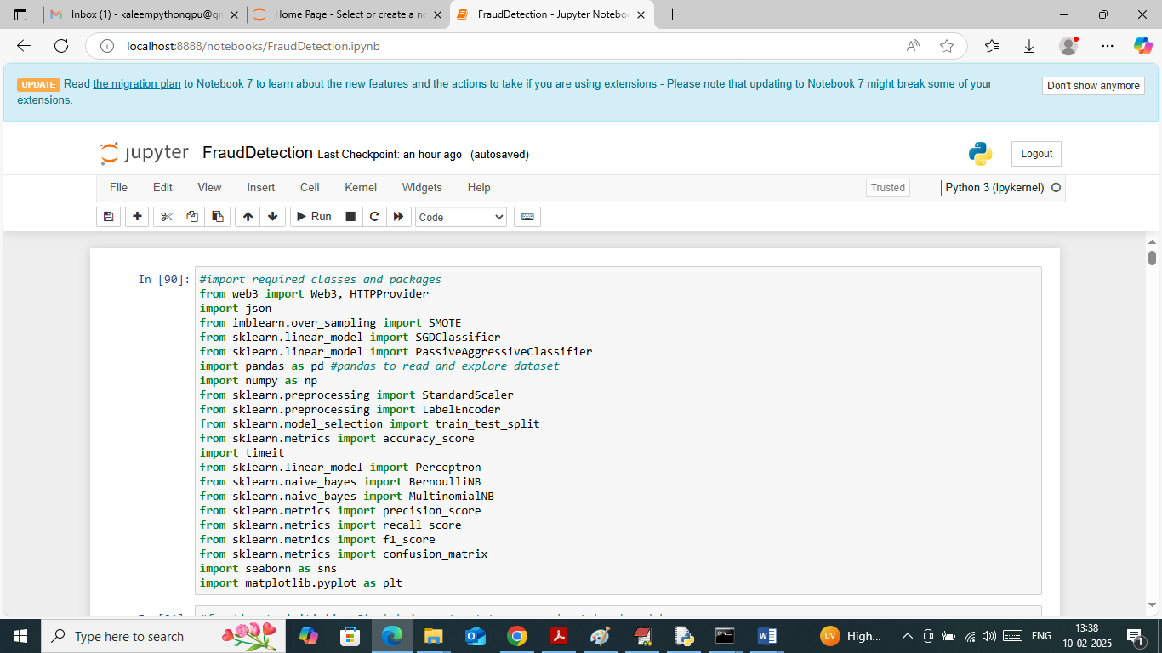
In above screen importing required python classes and packages
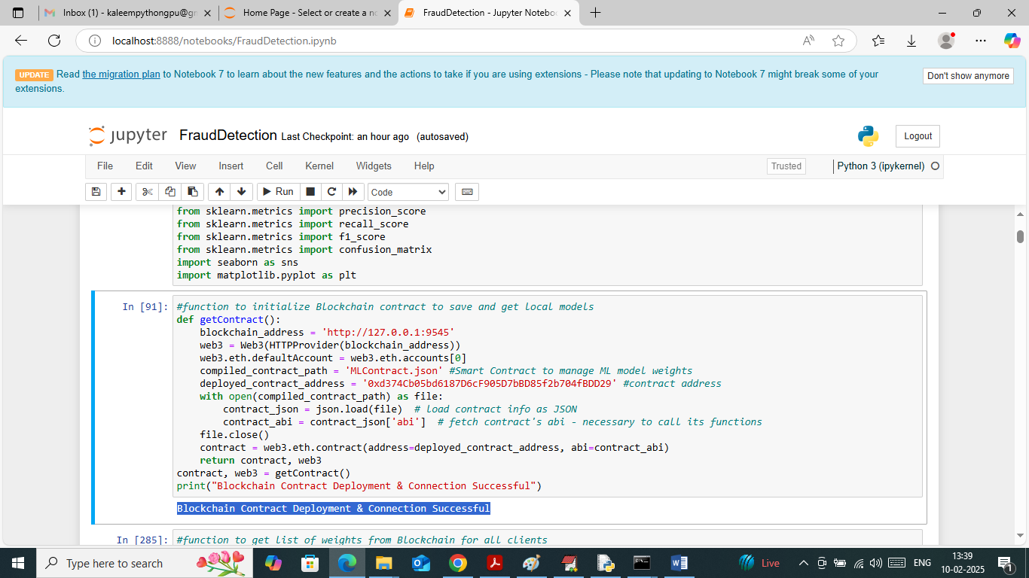
In above screen using contract address we are connecting to deployed smart contract running in Blockchain
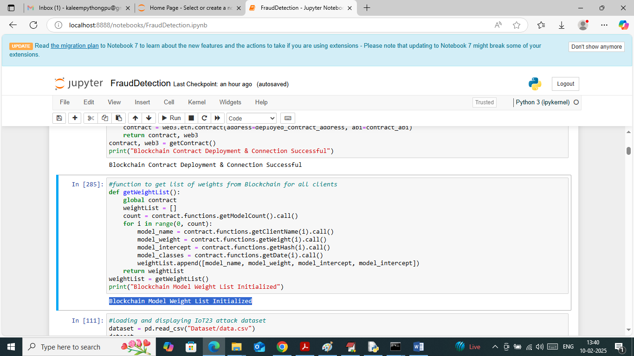
In above screen defining function to read existing available weights from Blockchain. In above screen connection to Blockchain successful
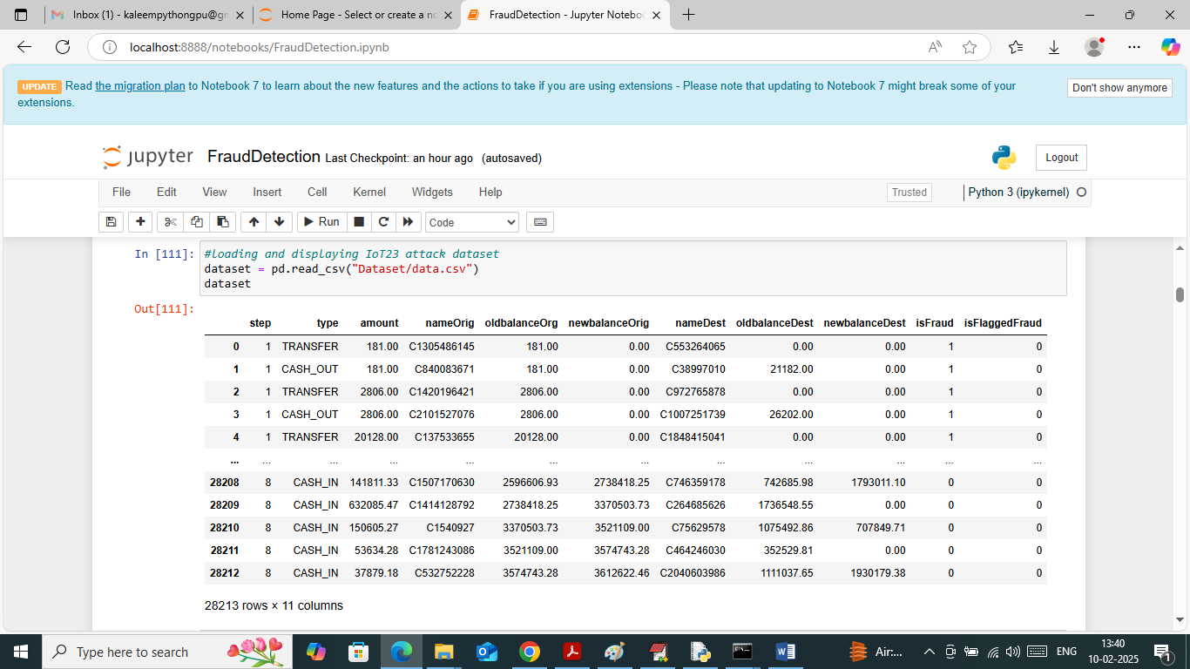
In above screen loading and displaying dataset values and above dataset contains some non-numeric values but ML take only numeric values so by applying Label Encoder class can convert non-numeric to numeric data
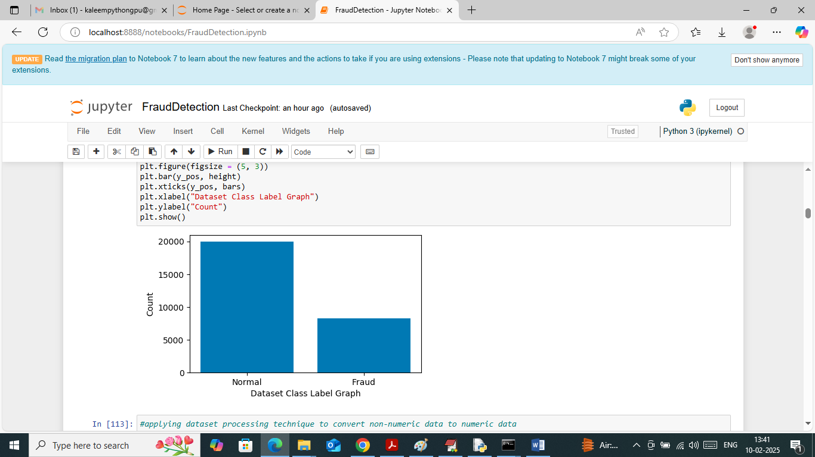
In above screen visualizing graph of normal and fraud transaction exists in dataset
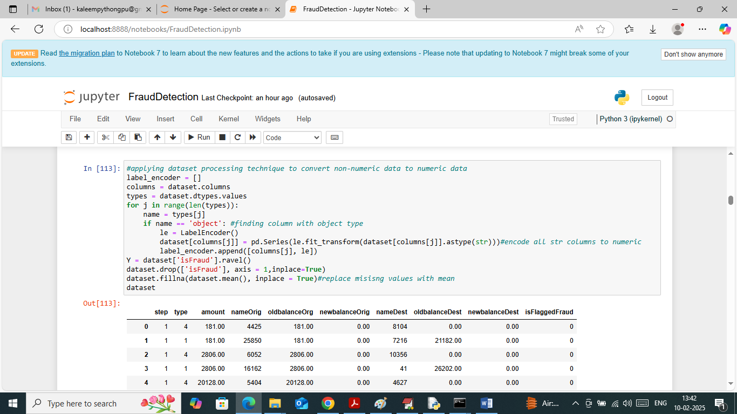
In above screen applying label encoder class to convert non-numeric data to numeric data and then replacing missing values with MEAN
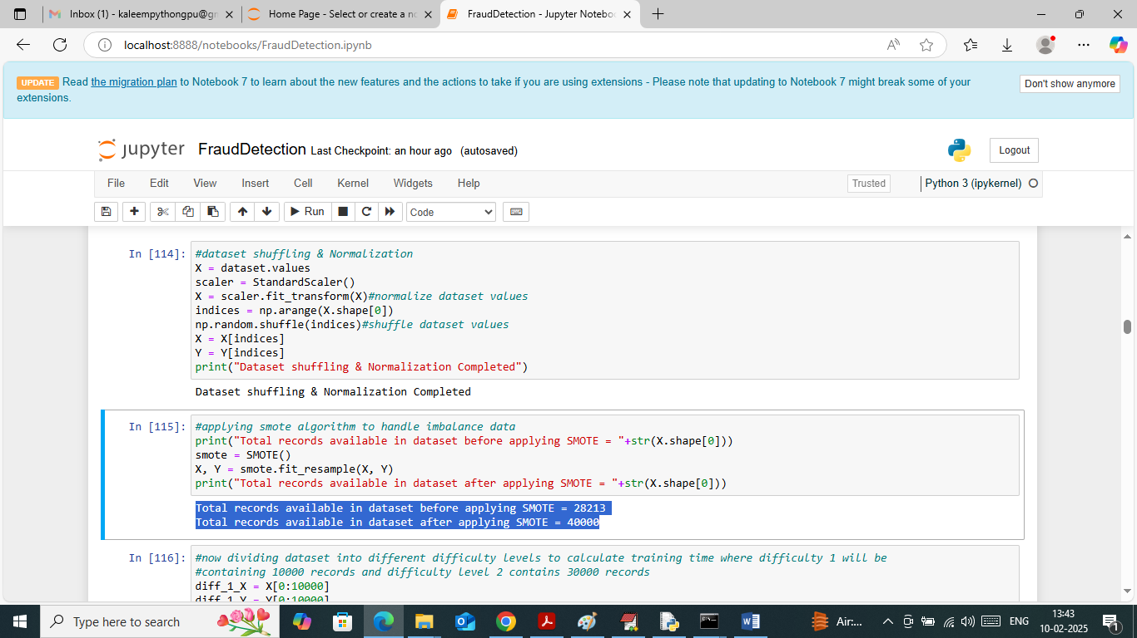
In above screen applying processing technique in first block to shuffle and normalized dataset values. In second block applying SMOTE technique to handle imbalance issues. In above screen before applying smote dataset were having 28000 records and after applying smote dataset size increased to 40000
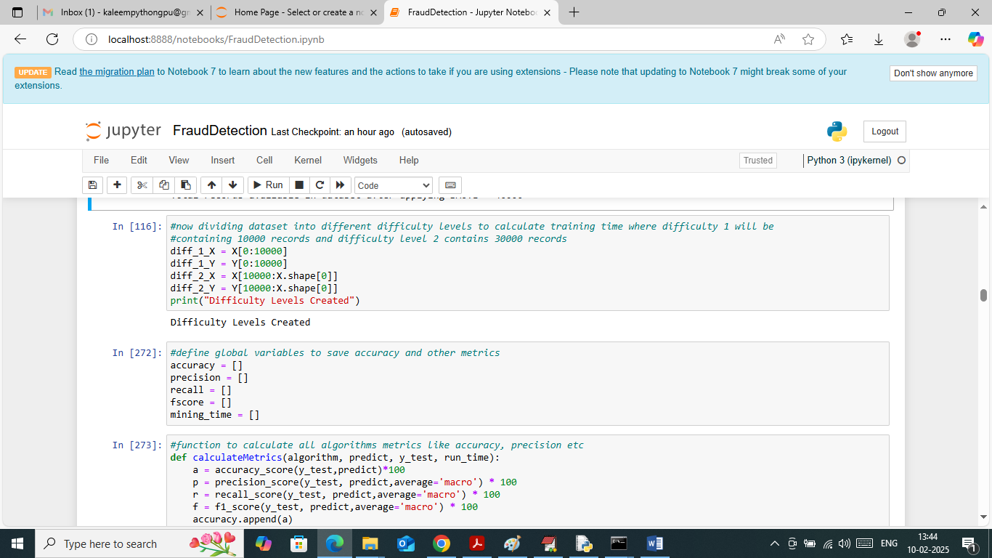
In above screen dividing dataset into two difficulty levels were difficulty 1 having 10000 records and difficulty 2 having 30000 records. In next blocks defining function to calculate accuracy and other metrics
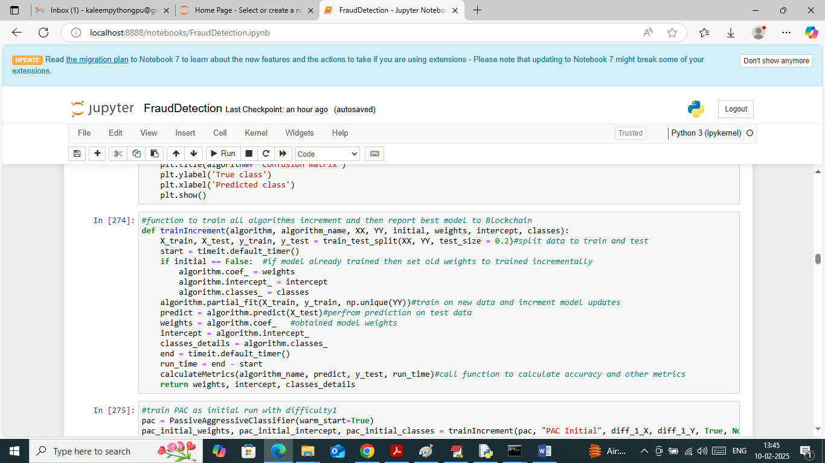
In above screen defining function to train algorithm incrementally and then calculate accuracy and other metrics and then getting weights to update to Blockchain
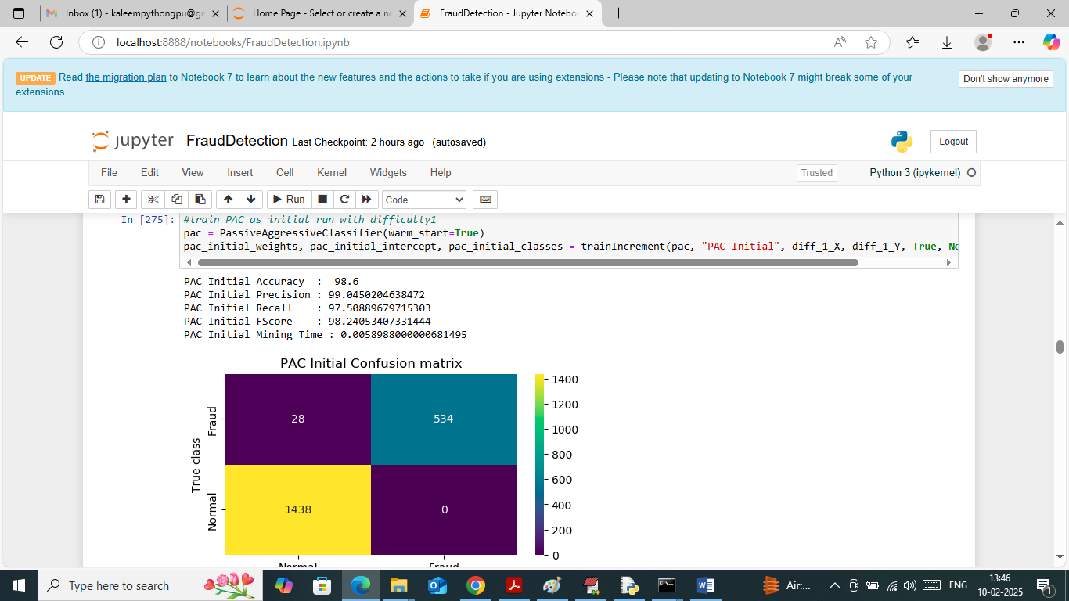
In above screen training PAC algorithm initially with difficulty 1 (10000 records) and then PAC got 98.6% accuracy and can see other metrics like precision, recall and FSCORE. In above confusion matrix graph x-axis represents Predicted Labels and y-axis represents True Labels (normal or fraud) and then yellow and light green boxes in diagonal represents correct prediction count and remaining blue boxes represents incorrect prediction count which are very few. In above screen can see training time also
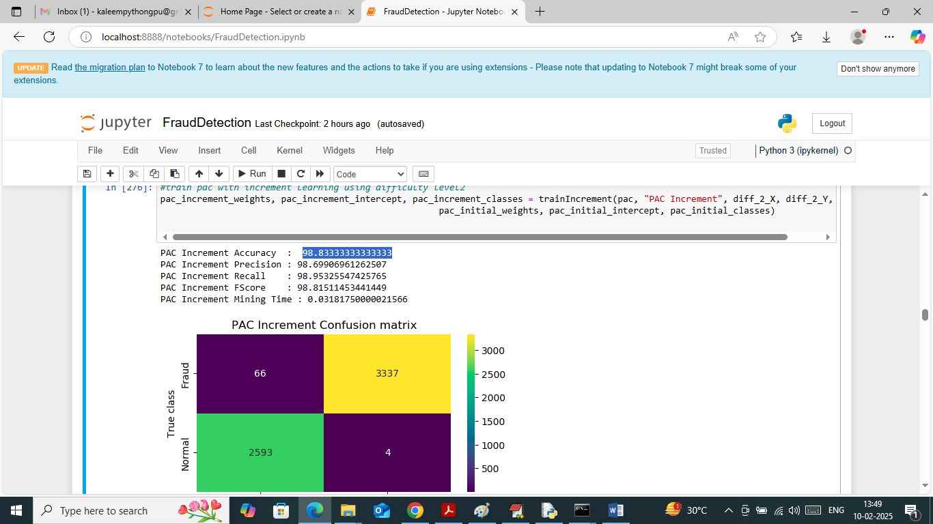
In above screen PAC trained incrementally on difficulty level 2 (30000 records) and then got 98.83% accuracy and can see other metrics output also
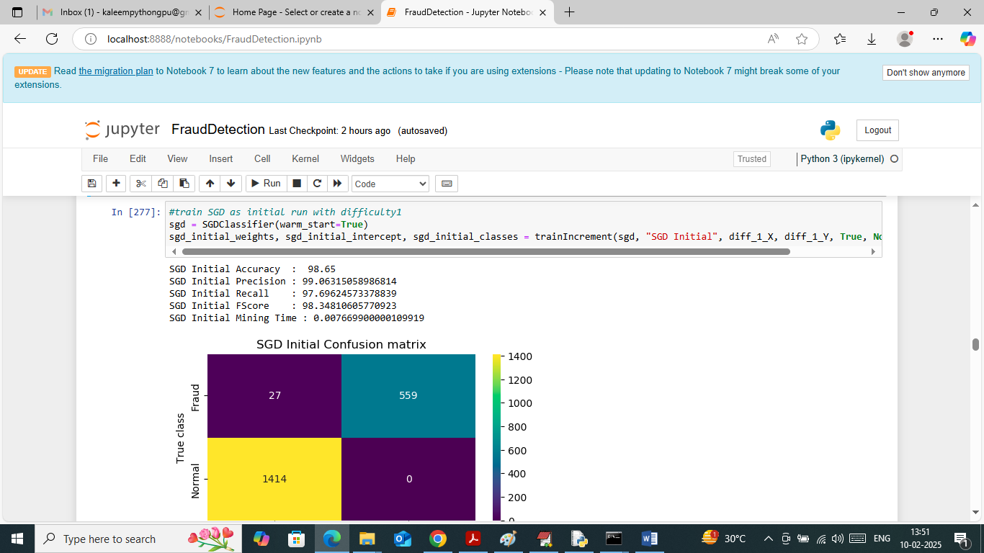
In above screen SGD on initial data got 98.65% accuracy
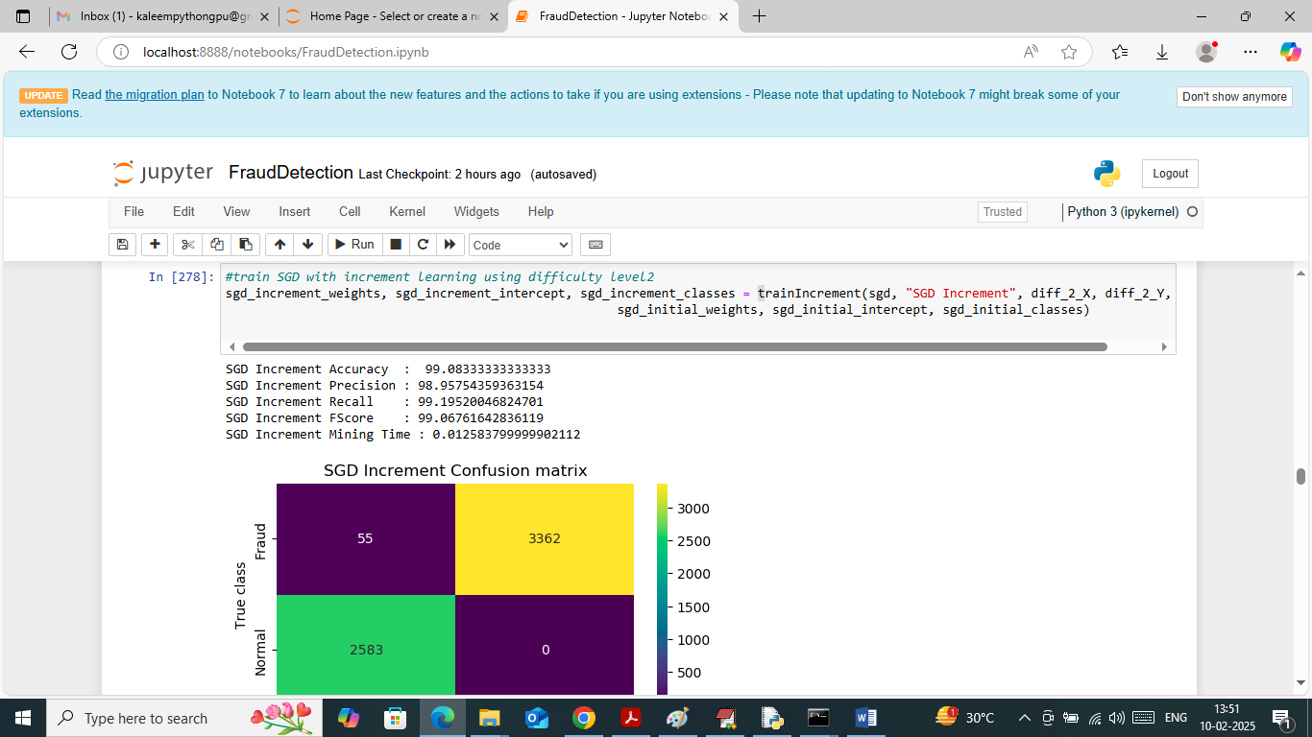
In above screen SGD on increment data got 99.83% accuracy
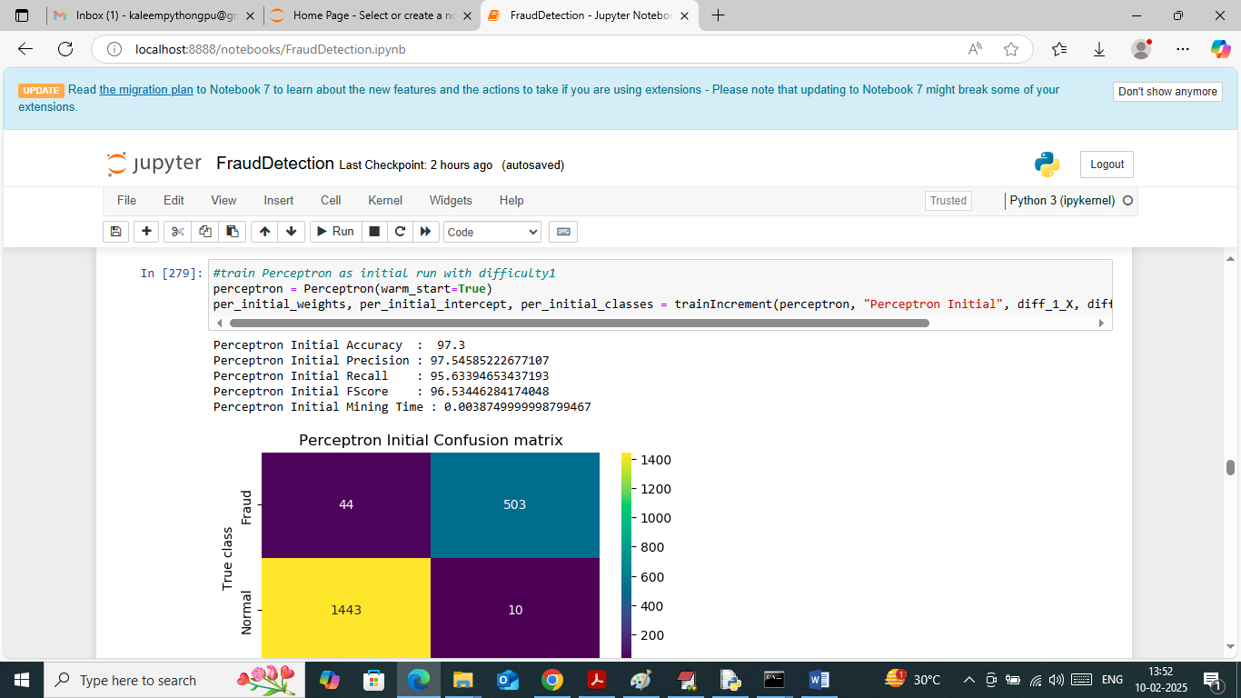
In above screen Perceptron got 97% accuracy on initial data
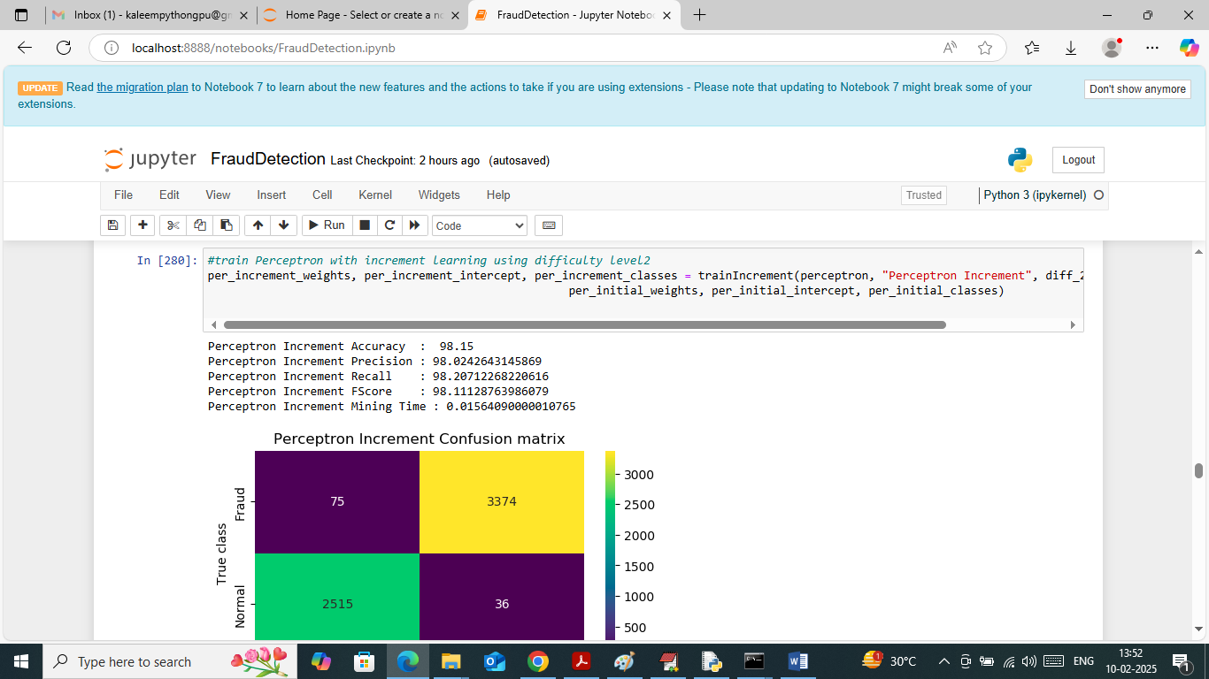
In above screen perceptron got 98% accuracy on increment training
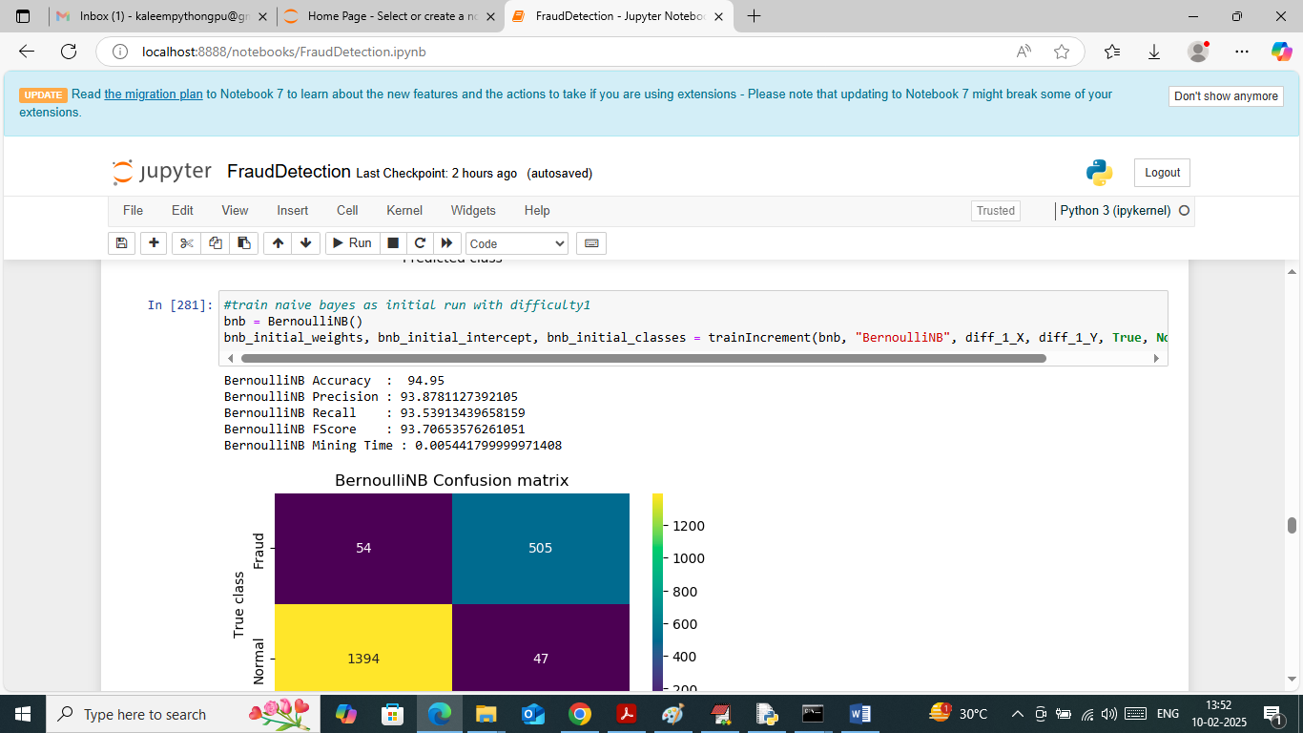
In above screen Naïve Bayes got 94% accuracy on initial data
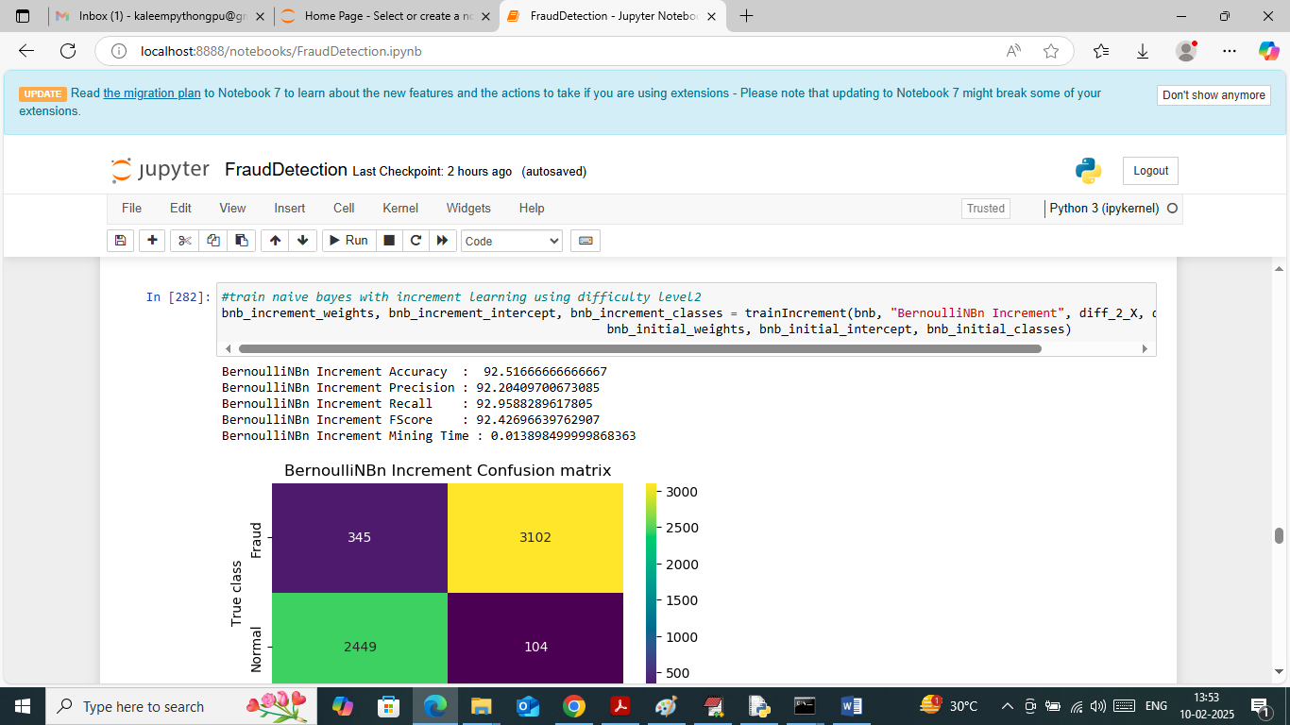
In above screen naïve bayes got 92% accuracy on increment training
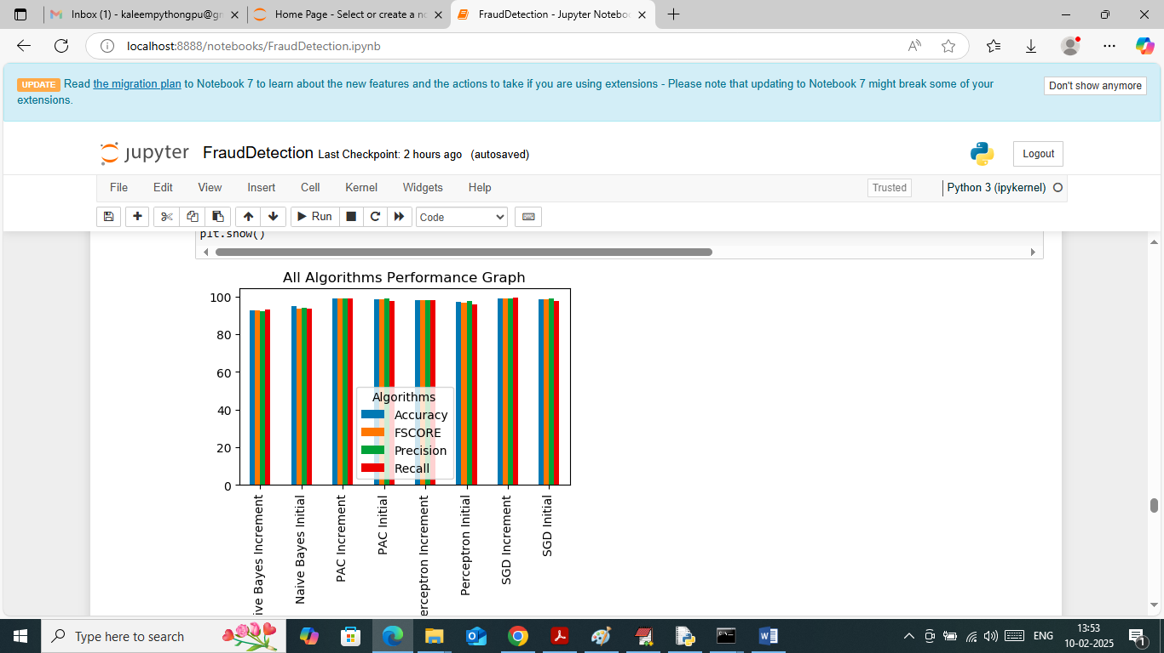
In above screen visualizing all algorithm performance where x-axis represents algorithm names and y-axis represents accuracy and other metrics in different colour bars.
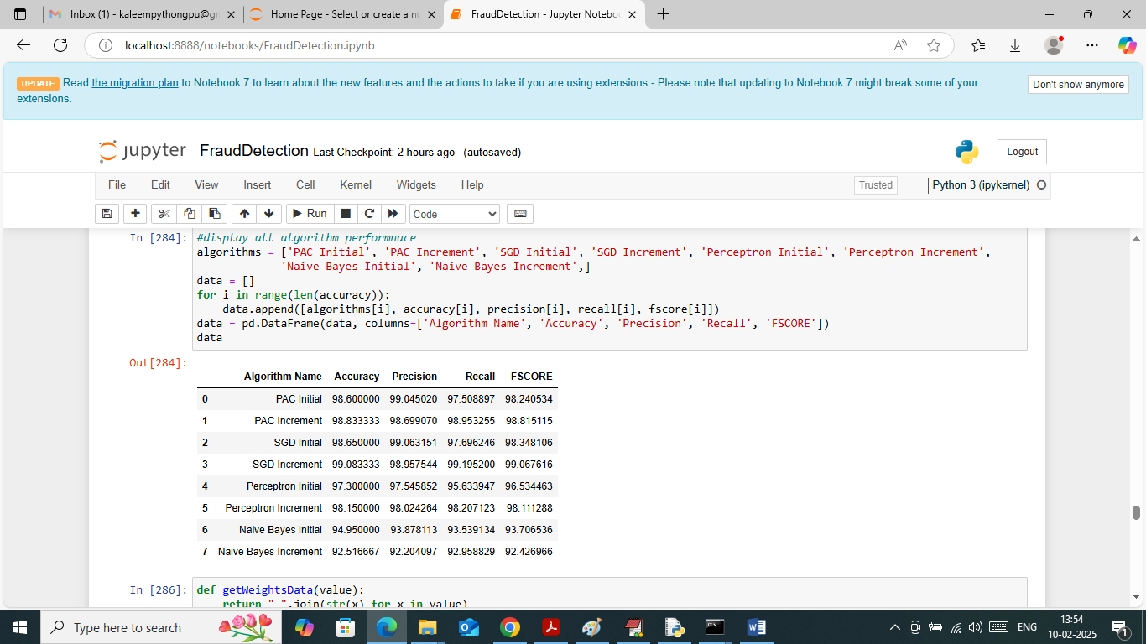
In above screen showing all algorithms performance in tabular format and in all algorithms SGD with increment training got high accuracy
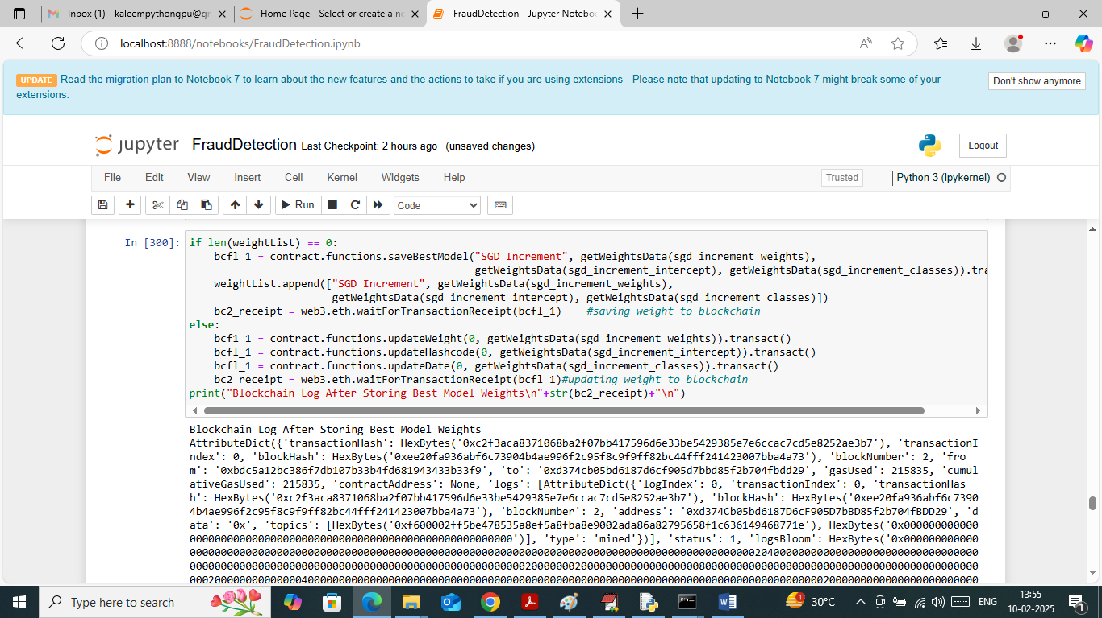
In above screen saving SGD weights to Blockchain as it got high accuracy and consider as best model. In above screen after saving weights to Blockchain we got all log details which contains details like Block No, transaction no, hash code and many other details.
IN ABOVE SCREENS WE TRAINED ML MODELS INCREMENTALLY AND THEN SAVE BEST WEIGHTS IN BLOCKCHAIN AND NOW WILL DETECT FRAUD TRANSACTION USING BELOW WEB OUTPUT
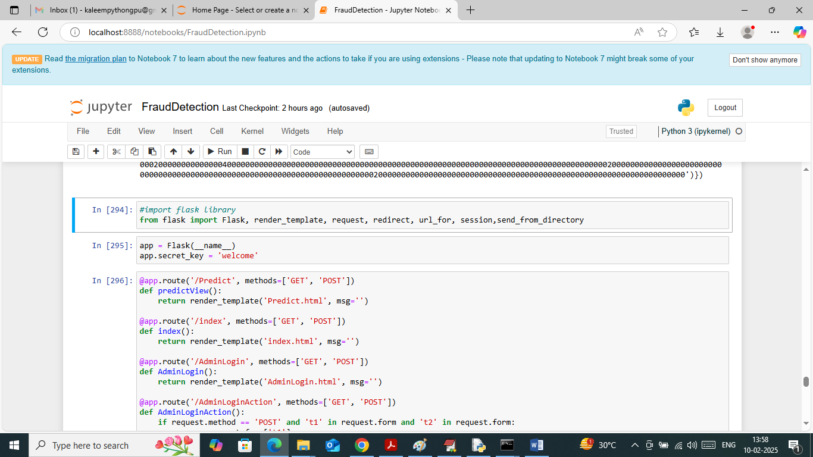
In above screen run all flask blocks to start FLASK web server and get below page
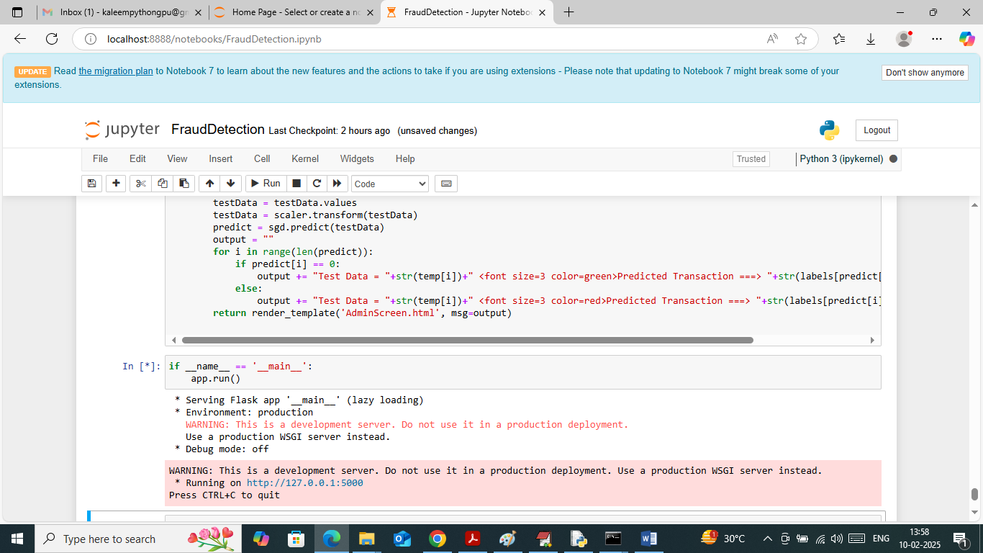
In above screen flask server started and now open browser and enter URL as http://127.0.0.1:5000/index and then press enter key to get below page
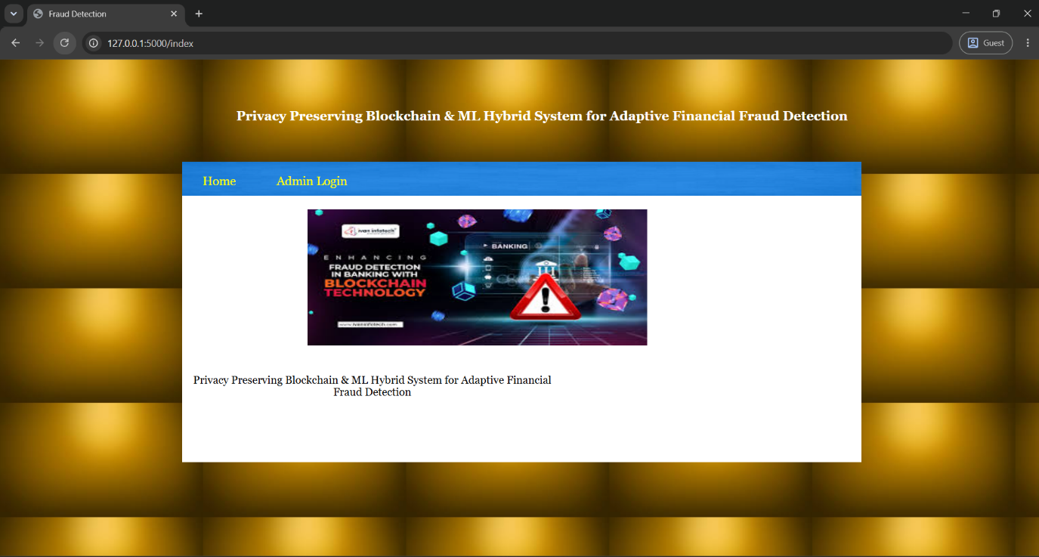
In above screen click on ‘Admin Login’ link to get below page
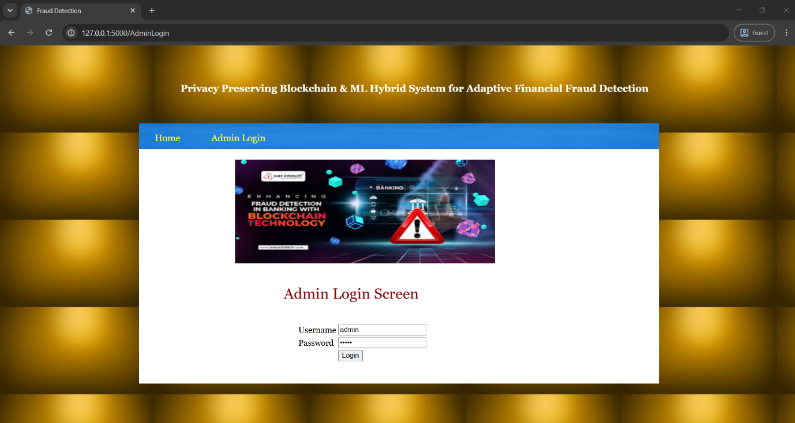
In above screen admin is login by using username and password as ‘admin and admin’ and after login will get below page
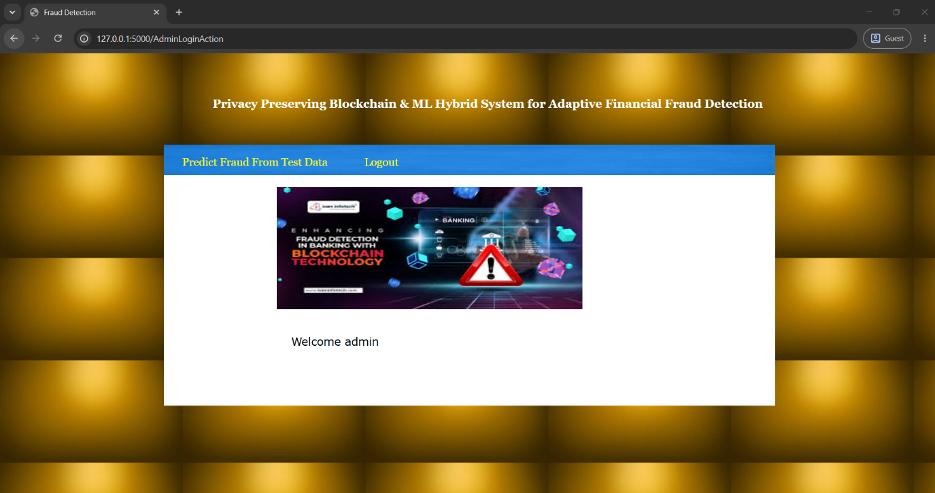
In above screen click on ‘Predict Fraud from Test Data’ link to get below page
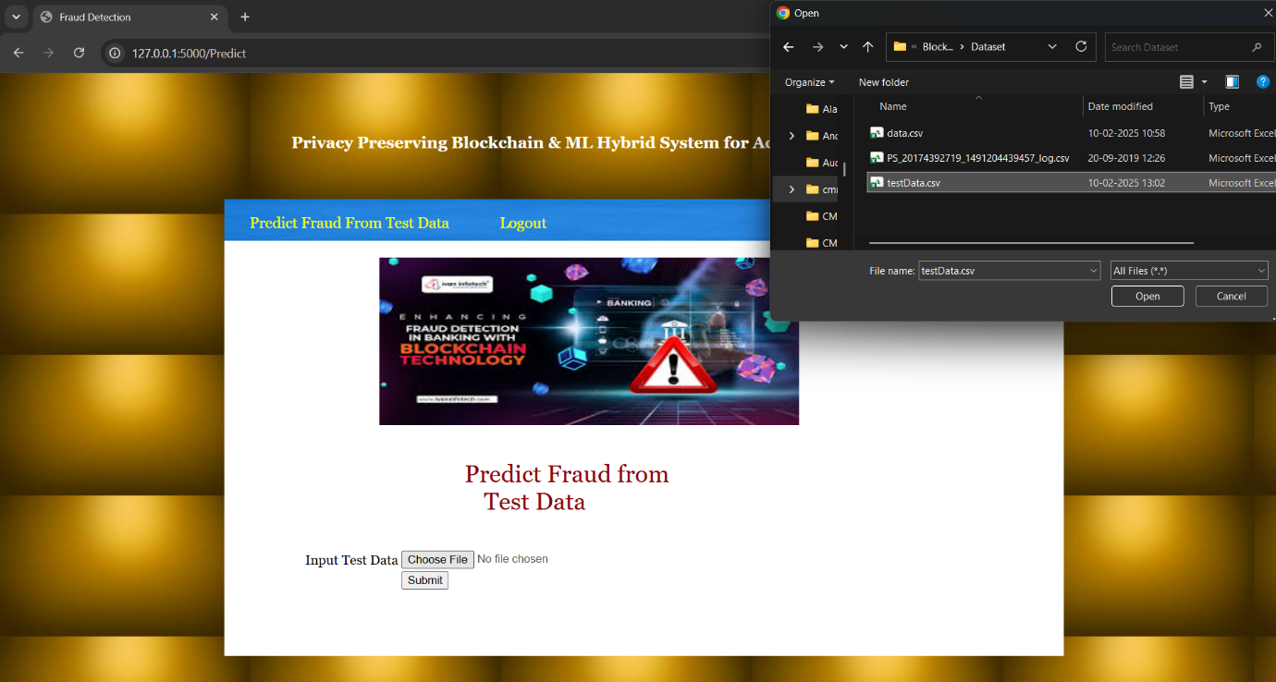
In above screen admin is selecting and uploading test transaction data and then click on ‘Open and submit’ button to get below page
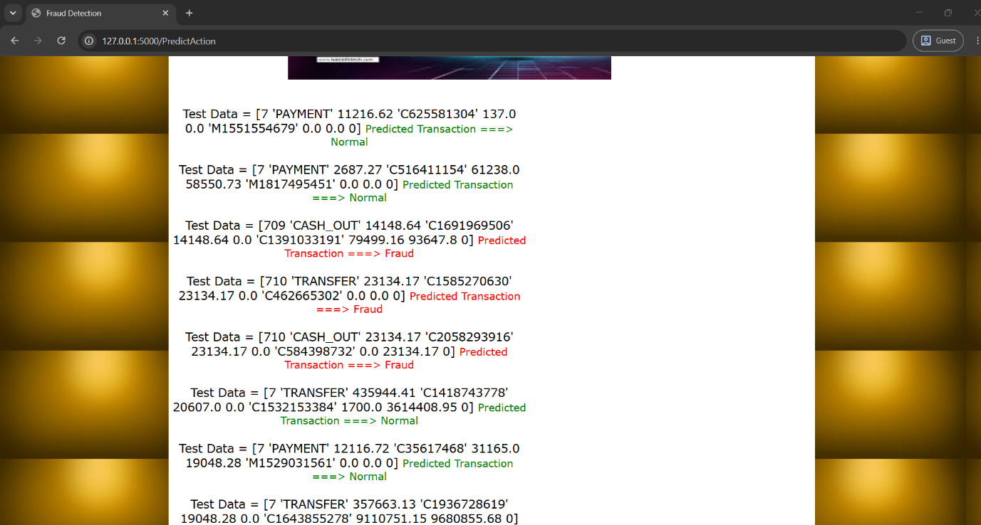
In above screen in square brackets admin can see Test data values and after = arrow symbol can see predicted values as Normal or Fraud for given test data.

CONCLUSION:
This study proposes an approach where e-commerce organizations can work collaboratively to build robust machine learning algorithms incrementally while safekeeping business strategies and mitigating privacy concerns. To bring robustness to current solutions, authentic data from the real marketplace is required. This study takes advantage of state-of-the-art blockchain technology to build a platform for training fraud detection ML algorithms incrementally and collaboratively while protecting the privacy of contributing organizations. Smart contracts have been used in this study to automate the process throughout the system with absolute sturdiness. No functionality within the system is alterable by anyone, and this establishes absolute trust among organizations to share their data safely. An adaptive incentive mechanism has been developed to encourage organizations by providing fair incentives. The reward calculated by the incentive mechanism is positively correlated with the difficulty of improving a model's performance. The more difficult it is to update a model, the more incentive will be disbursed by our system. Authentic data is more likely to impact the model's performance; hence, the real data provider gets highly incentivized.
By employing a thorough pre-deploy experiment, we chose the passive-aggressive classifier scoring 93.64% testing accuracy as the initial model. From data contributed by the organizations, the model incrementally learns within the blockchain network. The testing accuracy, F-beta score, precision, and recall reach close to 99% via incremental machine learning. The false-negative rate was brought down to 0.007% from a starting score of 0.04%. The confusion matrix of the increments shows that the false-negative amount decreases to 729 from 3922 as the model learns from new data and improves its capability. We also examined the mining time depending on the blockchain's difficulty level and the different volumes of data provided to the system. The result shows that for difficulty levels 2 and 3, and with varying amounts of data, the mining time is below a second. For difficulty level 3, a maximum of 3 seconds can be taken to mine a block. And for difficulty level 5, a much harder problem needs to be solved, and hence, the maximum mining time is approximately 70 seconds.
Our approach is generic to be applied in sectors where data privacy and security are essential, but collaboration among organizations can bring about much better performance and accuracy. For future studies, we intend to build class-adaptive solutions under a stream of data.

Future Scope:
- Integration with Real-Time Financial Systems
- Extend the system to work with live banking or e-commerce transaction streams (e.g., via APIs) for real-time fraud detection and prevention.
- Federated Learning Implementation
- Incorporate federated learning to enable multiple institutions to collaboratively train models without sharing sensitive data, further enhancing privacy.
- Cross-Blockchain Interoperability
- Develop smart contracts that support multi-chain compatibility (e.g., Ethereum, Polygon, Hyperledger) to ensure flexibility and lower transaction costs.
- Automated Model Update via Smart Contracts
- Implement a mechanism for on-chain model versioning and auto-updating of ML weights when new data is available, ensuring continuous learning and adaptation.
- Explainable AI (XAI) Integration
- Add interpretability modules that explain why a transaction is flagged as fraudulent, icreasing transparency and user trust.
- Enhanced Security with Zero-Knowledge Proofs (ZKP)
- Employ ZKPs to validate model updates or predictions on the blockchain without revealing sensitive transaction details.
REFERENCES:
[1] F. Beena, I. Mearaj, V. K. Shukla, and S. Anwar, ‘‘Mitigating financial fraud using data science—‘A case study on credit card frauds,’’’ in Proc. Int. Conf. Innov. Practices Technol. Manage. (ICIPTM), Noida, India, Feb. 2021.
[2] (2021). Online Payment Fraud Losses to Exceed $206 Billion Over the Next Five Years; Driven by Identity Fraud. Juniper Research. Accessed: Apr. 1, 2022. [Online]. Available: https://www. juniperresearch.com/press/online-payment-fraud-losses-exceed-206-bn
[3] S. A. Assefa, D. Dervovic, M. Mahfouz, R. E. Tillman, P. Reddy, and M. Veloso, ‘‘Generating synthetic data in finance: Opportunities, challenges and pitfalls,’’ in Proc. 1st ACM Int. Conf. AI Finance, Oct. 2020, no. 44, pp. 1–8.
[4] T. Amarasinghe, A. Aponso, and N. Krishnarajah, ‘‘Critical analysis of machine learning based approaches for fraud detection in financial transactions,’’ in Proc. Int. Conf. Mach. Learn. Technol. (ICMLT), May 2018, pp. 12–17.
[5] C. Rikap and B. Lundvall, ‘‘Tech giants and artificial intelligence as a technological innovation system,’’ in The Digital Innovation Race. Springer, 2021, pp. 65–90, doi: 10.1007/978-3-030-89443-6_4.
[6] J. Lu, W. Li, Q. Wang, and Y. Zhang, ‘‘Research on data quality control of crowdsourcing annotation: A survey,’’ in Proc. IEEE Int. Conf. Dependable, Autonomic Secure Comput., Int. Conf. Pervasive Intell. Comput., Int. Conf. Cloud Big Data Comput., Int. Conf. Cyber Sci. Techno. Congr. (DASC/PiCom/CBDCom/CyberSciTech), Calgary, AB, Canada, Aug. 2020, pp. 201–208.
[7] L. Ouyang, Y. Yuan, Y. Cao, and F.-Y. Wang, ‘‘A novel framework of collaborative early warning for COVID-19 based on blockchain and smart contracts,’’ Inf. Sci., vol. 570, pp. 124–143, Sep. 2021.
[8] G. I. Parisi, R. Kemker, J. L. Part, C. Kanan, and S. Wermter, ‘‘Continual lifelong learning with neural networks: A review,’’ Neural Netw., vol. 113, pp. 54–71, May 2019.
[9] T. Barry, ‘‘A comparative approach between batch and online machine learning for predicting next-minute cryptocurrency price direction,’’ Ph.D. dissertation, Nat. College Ireland, Dublin, Ireland, 2021.
[10] H. M. Gomes, J. Read, A. Bifet, J. P. Barddal, and J. Gama, ‘‘Machine learning for streaming data: State of the art, challenges, and opportunities,’’ ACM SIGKDD Explorations Newslett., vol. 21, no. 2, pp. 6–22, Nov. 2019.
[11] S. C. H. Hoi, D. Sahoo, J. Lu, and P. Zhao, ‘‘Online learning: A comprehensive survey,’’ Neurocomputing, vol. 459, pp. 249–289, Oct. 2021.
[12] C. Yang, ‘‘Incremental outlier feature clustering algorithm in blockchain networks based on big data analysis,’’ IETE J. Res., pp. 1–9, Apr. 2022.
[13] Z. Shahbazi and Y.-C. Byun, ‘‘Integration of blockchain, IoT and machine learning for multistage quality control and enhancing security in smart manufacturing,’’ Sensors, vol. 21, no. 4, p. 1467, Feb. 2021.
[14] J. D. Harris and B. Waggoner, ‘‘Decentralized and collaborative AI on blockchain,’’ in Proc. IEEE Int. Conf. Blockchain (Blockchain), Jan. 2019, pp. 368–375.
[15] C. Ma, X. Kong, Q. Lan, and Z. Zhou, ‘‘The privacy protection mechanism of hyperledger fabric and its application in supply chain finance,’’ Cybersecurity, vol. 2, no. 1, pp. 1–9, Dec. 2019.
[16] F. Chen, H. Wan, H. Cai, and G. Cheng, ‘‘Machine learning in/for blockchain: Future and challenges,’’ Can. J. Statist., vol. 49, no. 4, pp. 1364–1382, Dec. 2021.
[17] M. Niranjanamurthy, B. N. Nithya, and S. Jagannatha, ‘‘Analysis of blockchain technology: Pros, cons and SWOT,’’ Cluster Comput., vol. 22, no. S6, pp. 14743–14757, Nov. 2019.
[18] M. Nofer, P. Gomber, O. Hinz, and D. Schiereck, ‘‘Blockchain,’’ Bus. Inf. Syst. Eng., vol. 59, no. 3, pp. 183–187, Mar. 2017.
[19] A. B. Haque, A. K. M. N. Islam, S. Hyrynsalmi, B. Naqvi, and K. Smolander, ‘‘GDPR compliant blockchains—A systematic literature review,’’ IEEE Access, vol. 9, pp. 50593–50606, 2021.
[20] Y. Chen and C. Bellavitis, ‘‘Blockchain disruption and decentralized finance: The rise of decentralized business models,’’ J. Bus. Venturing Insights, vol. 13, Jun. 2020, Art. no. e00151.
[21] F. Hofmann, S. Wurster, E. Ron, and M. Bohmecke-Schwafert, ‘‘The immutability concept of blockchains and benefits of early standardization,’’ in Proc. ITU Kaleidoscope, Challenges Data-Driven Soc. (ITU K), Nanjing, China, Nov. 2017, pp. 1–8.
[22] F. Rizal Batubara, J. Ubacht, and M. Janssen, ‘‘Unraveling transparency and accountability in blockchain,’’ in Proc. 20th Annu. Int. Conf. Digit. Government Res., Jun. 2019, pp. 204–213.
[23] W. Zheng, Z. Zheng, X. Chen, K. Dai, P. Li, and R. Chen, ‘‘NutBaaS: A blockchain-as-a-service platform,’’ IEEE Access, vol. 7, pp. 134422–134433, 2019.
[24] J. R. Varma, ‘‘Blockchain in finance,’’ Vikalpa, vol. 44, no. 1, pp. 1–11, 2019.
[25] M. Iqbal and R. Matulevičius, ‘‘Exploring sybil and double-spending risks in blockchain systems,’’ IEEE Access, vol. 9, pp. 76153–76177, 2021.
[26] R. Roriz and J. L. Pereira, ‘‘Avoiding insurance fraud: A blockchain-based solution for the vehicle sector,’’ Proc. Comput. Sci., vol. 164, pp. 211–218, Jun. 2019.
[27] T. McGhin, K.-K. R. Choo, C. Z. Liu, and D. He, ‘‘Blockchain in healthcare applications: Research challenges and opportunities,’’ J. Netw. Comput. Appl., vol. 135, pp. 62–75, Jun. 2019.
[28] P. Bhaskar, C. K. Tiwari, and A. Joshi, ‘‘Blockchain in education management: Present and future applications,’’ Interact. Technol. Smart Educ., vol. 18, no. 1, pp. 1–17, Nov. 2020.
[29] G. S. Leite, A. B. Albuquerque, and P. R. Pinheiro, ‘‘Process automation and blockchain in intelligence and investigation units: An approach,’’ Appl. Sci., vol. 10, no. 11, p. 3677, May 2020.
[30] M. M. Queiroz, R. Telles, and S. H. Bonilla, ‘‘Blockchain and supply chain management integration: A systematic review of the literature,’’ Supply Chain Manag., Int. J., vol. 25, no. 2, pp. 241–254, Aug. 2019.
[31] N. Szabo, ‘‘Formalizing and securing relationships on public networks,’’ 1st Monday, vol. 2, no. 9, Sep. 1997. [Online]. Available: https://journals.uic.edu/ojs/index.php/fm/article/view/548
[32] S. Aggarwal and N. Kumar, ‘‘Blockchain 2.0: Smart contracts,’’ Adv. Comput., vol. 121, pp. 301–322, Sep. 2021.
[33] L. Liu, W.-T. Tsai, M. Z. A. Bhuiyan, H. Peng, and M. Liu, ‘‘Blockchainenabled fraud discovery through abnormal smart contract detection on Ethereum,’’ Future Gener. Comput. Syst., vol. 128, pp. 158–166, Mar. 2022.
[34] P. Sharma, M. D. Borah, and S. Namasudra, ‘‘Improving security of medical big data by using blockchain technology,’’ Comput. Electr. Eng., vol. 96, Dec. 2021, Art. no. 107529.
[35] W. Tan, H. Zhu, J. Tan, Y. Zhao, L. D. Xu, and K. Guo, ‘‘A novel service level agreement model using blockchain and smart contract for cloud manufacturing in Industry 4.0,’’ Enterprise Inf. Syst., vol. 10, pp. 1–26, Jun. 2021.
[36] N. Malsa, V. Vyas, J. Gautam, R. N. Shaw, and A. Ghosh, ‘‘Framework and smart contract for blockchain enabled certificate verification system using robotics,’’ in Machine Learning for Robotics Applications, vol. 960. Cham, Switzerland: Springer, Apr. 2021, pp. 125–138.
[37] Q. Yang, Y. Gu, and D. Wu, ‘‘Survey of incremental learning,’’ in Proc. Chin. Control Decis. Conf. (CCDC), Nanchang, China, Jun. 2019, pp. 399–404.
[38] M. Nilashi, O. Ibrahim, H. Ahmadi, L. Shahmoradi, and M. Farahmand, ‘‘A hybrid intelligent system for the prediction of Parkinson’s disease progression using machine learning techniques,’’ Biocybern. Biomed. Eng., vol. 38, no. 1, pp. 1–15, 2018.
[39] H. Tian, M. Shuai, K. Li, and X. Peng, ‘‘An incremental learning ensemble strategy for industrial process soft sensors,’’ Complexity, vol. 2019, pp. 1–12, May 2019.
[40] Y. Lin, G. Vosselman, Y. Cao, and M. Y. Yang, ‘‘Active and incremental learning for semantic ALS point cloud segmentation,’’ ISPRS J. Photogramm. Remote Sens., vol. 169, pp. 73–92, Nov. 2020.
[41] L. Fu, X. Li, L. Zi, Z. Zhang, Y. Wu, X. He, and B. Zhou, ‘‘Incremental learning for end-to-end automatic speech recognition,’’ in Proc. IEEE Autom. Speech Recognit. Understand. Workshop (ASRU), Cartagena, Colombia, Dec. 2021, pp. 320–327.
[42] J. He, R. Mao, Z. Shao, and F. Zhu, ‘‘Incremental learning in online scenario,’’ in Proc. IEEE/CVF Conf. Comput. Vis. Pattern Recognit. (CVPR), Seattle, WA, USA, Jun. 2020, pp. 13926–13935.
[43] K. D. Martin, A. Borah, and R. W. Palmatier, ‘‘Data privacy: Effects on customer and firm performance,’’ J. Marketing, vol. 81, no. 1, pp. 36–58, Jan. 2017.
[44] S. Vyas, M. Gupta, and R. Yadav, ‘‘Converging blockchain and machine learning for healthcare,’’ in Proc. Amity Int. Conf. Artif. Intell. (AICAI), Dubai, UAE, Feb. 2019, pp. 709–711.
[45] M. U. Hassan, M. H. Rehmani, and J. Chen, ‘‘Differential privacy in blockchain technology: A futuristic approach,’’ J. Parallel Distrib. Comput., vol. 145, pp. 50–74, Nov. 2020.

